JavaScript notes
JavaScript is an object-based scripting language which is lightweight and cross-platform.
JavaScript is not a compiled language, but it is a translated language. The JavaScript Translator (embedded in the browser) is responsible for translating the JavaScript code for the web browser.

What is JavaScript
JavaScript (js) is a light-weight object-oriented programming language which is used by several websites for scripting the webpages. It is an interpreted, full-fledged programming language that enables dynamic interactivity on websites when applied to an HTML document. It was introduced in the year 1995 for adding programs to the webpages in the Netscape Navigator browser. Since then, it has been adopted by all other graphical web browsers. With JavaScript, users can build modern web applications to interact directly without reloading the page every time. The traditional website uses js to provide several forms of interactivity and simplicity.
Although, JavaScript has no connectivity with Java programming language. The name was suggested and provided in the times when Java was gaining popularity in the market. In addition to web browsers, databases such as CouchDB and MongoDB uses JavaScript as their scripting and query language.

Features of JavaScript
There are following features of JavaScript:
- All popular web browsers support JavaScript as they provide built-in execution environments.
- JavaScript follows the syntax and structure of the C programming language. Thus, it is a structured programming language.
- JavaScript is a weakly typed language, where certain types are implicitly cast (depending on the operation).
- JavaScript is an object-oriented programming language that uses prototypes rather than using classes for inheritance.
- It is a light-weighted and interpreted language.
- It is a case-sensitive language.
- JavaScript is supportable in several operating systems including, Windows, macOS, etc.
- It provides good control to the users over the web browsers.

History of JavaScript
In 1993, Mosaic, the first popular web browser, came into existence. In the year 1994, Netscape was founded by Marc Andreessen. He realized that the web needed to become more dynamic. Thus, a 'glue language' was believed to be provided to HTML to make web designing easy for designers and part-time programmers. Consequently, in 1995, the company recruited Brendan Eich intending to implement and embed Scheme programming language to the browser. But, before Brendan could start, the company merged with Sun Microsystems for adding Java into its Navigator so that it could compete with Microsoft over the web technologies and platforms. Now, two languages were there: Java and the scripting language. Further, Netscape decided to give a similar name to the scripting language as Java's. It led to 'Javascript'. Finally, in May 1995, Marc Andreessen coined the first code of Javascript named 'Mocha'. Later, the marketing team replaced the name with 'LiveScript'. But, due to trademark reasons and certain other reasons, in December 1995, the language was finally renamed to 'JavaScript'. From then, JavaScript came into existence.

Application of JavaScript
JavaScript is used to create interactive websites. It is mainly used for:
- Client-side validation,
- Dynamic drop-down menus,
- Displaying date and time,
- Displaying pop-up windows and dialog boxes (like an alert dialog box, confirm dialog box and prompt dialog box),
- Displaying clocks etc.

JavaScript Example

- <script>
- document.write("Hello JavaScript by JavaScript");
- </script>

JavaScript Example
- JavaScript Example
- Within body tag
- Within head tag
Javascript example is easy to code. JavaScript provides 3 places to put the JavaScript code: within body tag, within head tag and external JavaScript file.
Let’s create the first JavaScript example.
<script type="text/javascript">
document.write("JavaScript is a simple language for learners");
</script>

The script tag specifies that we are using JavaScript.
The text/javascript is the content type that provides information to the browser about the data.
The document.write() function is used to display dynamic content through JavaScript. We will learn about document object in detail later.

3 Places to put JavaScript code
- Between the body tag of html
- Between the head tag of html
- In .js file (external javaScript)

1) JavaScript Example : code between the body tag
In the above example, we have displayed the dynamic content using JavaScript. Let’s see the simple example of JavaScript that displays alert dialog box.
- <script type="text/javascript">
- alert("Hello JavaScript");
- </script>

2) JavaScript Example : code between the head tag
Let’s see the same example of displaying alert dialog box of JavaScript that is contained inside the head tag.
In this example, we are creating a function msg(). To create function in JavaScript, you need to write function with function_name as given below.
To call function, you need to work on event. Here we are using onclick event to call msg() function.
<html>
<head>
<script type="text/javascript">
function msg()
{
alert("Hello JavaScipt");
}
</script>
</head>
<body>
<p>Welcome to JavaScript</p>
<form>
<input type="button" value="click" onclick="msg()"/>
</form>
</body>
</html>

External JavaScript file
We can create external JavaScript file and embed it in many html page.
It provides code re usability because single JavaScript file can be used in several html pages.
An external JavaScript file must be saved by .js extension. It is recommended to embed all JavaScript files into a single file. It increases the speed of the webpage.
Let's create an exte rnal JavaScript file that prints Hello Java in a alert dialog box.
message.js
- function msg(){
- alert("Hello JavaScript");
- }
Let's include the JavaScript file into html page. It calls the JavaScript function on button click.
index.html
<html>
<head>
<script type="text/javascript" src="message.js"></script>
</head>
<body>
<p>Welcome to JavaScript</p>
<form>
<input type="button" value="click" onclick="msg()"/>
</form>
</body>
</html>

Advantages of External JavaScript
There will be following benefits if a user creates an external javascript:
- It helps in the reusability of code in more than one HTML file.
- It allows easy code readability.
- It is time-efficient as web browsers cache the external js files, which further reduces the page loading time.
- It enables both web designers and coders to work with html and js files parallelly and separately, i.e., without facing any code conflictions.
- The length of the code reduces as only we need to specify the location of the js file.

Disadvantages of External JavaScript
There are the following disadvantages of external files:
- The stealer may download the coder's code using the url of the js file.
- If two js files are dependent on one another, then a failure in one file may affect the execution of the other dependent file.
- The web browser needs to make an additional http request to get the js code.
- A tiny to a large change in the js code may cause unexpected results in all its dependent files.
- We need to check each file that depends on the commonly created external javascript file.
- If it is a few lines of code, then better to implement the internal javascript code.

JavaScript Comment
The JavaScript comments are meaningful way to deliver message. It is used to add information about the code, warnings or suggestions so that end user can easily interpret the code.
The JavaScript comment is ignored by the JavaScript engine i.e. embedded in the browser.

Advantages of JavaScript comments
There are mainly two advantages of JavaScript comments.
- To make code easy to understand It can be used to elaborate the code so that end user can easily understand the code.
- To avoid the unnecessary code It can also be used to avoid the code being executed. Sometimes, we add the code to perform some action. But after sometime, there may be need to disable the code. In such case, it is better to use comments.

Types of JavaScript Comments
There are two types of comments in JavaScript.
- Single-line Comment
- Multi-line Comment

JavaScript Single line Comment
It is represented by double forward slashes (//). It can be used before and after the statement.
Let’s see the example of single-line comment i.e. added before the statement.
- <script>
- // It is single line comment
- document.write("hello javascript");
- </script>
Test it Now
Let’s see the example of single-line comment i.e. added after the statement.
- <script>
- var a=10;
- var b=20;
- var c=a+b;//It adds values of a and b variable
- document.write(c);//prints sum of 10 and 20
- </script>
Test it Now

JavaScript Multi line Comment
It can be used to add single as well as multi line comments. So, it is more convenient.
It is represented by forward slash with asterisk then asterisk with forward slash. For example:
- /* your code here */
It can be used before, after and middle of the statement.
- <script>
- /* It is multi line comment.
- It will not be displayed */
- document.write("example of javascript multiline comment");
- </script>

JavaScript Variable
A JavaScript variable is simply a name of storage location. There are two types of variables in JavaScript : local variable and global variable.
There are some rules while declaring a JavaScript variable (also known as identifiers).
- Name must start with a letter (a to z or A to Z), underscore( _ ), or dollar( $ ) sign.
- After first letter we can use digits (0 to 9), for example value1.
- JavaScript variables are case sensitive, for example x and X are different variables.

Correct JavaScript variables
- var x1 = 10;
- var _value="sonoo";

Incorrect JavaScript variables
- var 123=30;
- var *aa=320;

Example of JavaScript variable
Let’s see a simple example of JavaScript variable.
- <script>
- var x = 10;
- var y = 20;
- var z=x+y;
- document.write(z);
- </script>

JavaScript local variable
A JavaScript local variable is declared inside block or function. It is accessible within the function or block only. For example:
- <script>
- function abc(){
- var x=10;//local variable
- }
- </script>
Or,
- <script>
- If(10<13){
- var y=20;//JavaScript local variable
- }
- </script>

JavaScript global variable
A JavaScript global variable is accessible from any function. A variable i.e. declared outside the function or declared with window object is known as global variable. For example:
<script>
var data=200;//gloabal variable
function a(){
document.writeln(data);
}
function b(){
document.writeln(data);
}
a();//calling JavaScript function
b();
</script>

JavaScript Global Variable
A JavaScript global variable is declared outside the function or declared with window object. It can be accessed from any function.
Let’s see the simple example of global variable in JavaScript.
- <script>
- var value=50;//global variable
- function a(){
- alert(value);
- }
- function b(){
- alert(value);
- }
- </script>

Declaring JavaScript global variable within function
To declare JavaScript global variables inside function, you need to use window object. For example:
- window.value=90;
Now it can be declared inside any function and can be accessed from any function. For example:
- function m(){
- window.value=100;//declaring global variable by window object
- }
- function n(){
- alert(window.value);//accessing global variable from other function
- }

Internals of global variable in JavaScript
When you declare a variable outside the function, it is added in the window object internally. You can access it through window object also. For example:
- var value=50;
- function a(){
- alert(window.value);//accessing global variable
- }

Javascript Data Types
JavaScript provides different data types to hold different types of values. There are two types of data types in JavaScript.
- Primitive data type
- Non-primitive (reference) data type
JavaScript is a dynamic type language, means you don't need to specify type of the variable because it is dynamically used by JavaScript engine. You need to use var here to specify the data type. It can hold any type of values such as numbers, strings etc. For example:
- var a=40;//holding number
- var b="Rahul";//holding string

JavaScript primitive data types
There are five types of primitive data types in JavaScript. They are as follows:
Data Type | Description
String | represents sequence of characters e.g. "hello"
Number | represents numeric values e.g. 100
Boolean | represents boolean value either false or true
Undefined | represents undefined value
Null | represents null i.e. no value at all

JavaScript non-primitive data types
The non-primitive data types are as follows:
Data Type | Description
Object | represents instance through which we can access members
Array | represents group of similar values
RegExp | represents regular expression

JavaScript Operators
JavaScript operators are symbols that are used to perform operations on operands. For example:
- var sum=10+20;
Here, + is the arithmetic operator and = is the assignment operator.
There are following types of operators in JavaScript.
- Arithmetic Operators
- Comparison (Relational) Operators
- Bitwise Operators
- Logical Operators
- Assignment Operators
- Special Operators

JavaScript Arithmetic Operators
Arithmetic operators are used to perform arithmetic operations on the operands. The following operators are known as JavaScript arithmetic operators.
Operator | Description | Example
+ | Addition | 10+20 = 30
- | Subtraction | 20-10 = 10
* | Multiplication | 10*20 = 200
/ | Division | 20/10 = 2
% | Modulus (Remainder) | 20%10 = 0
++ | Increment | <html>  <head>  <title>rect</title>  </head>  <body>  <script type="text/javascript">  var a,b,c;  a=20;  b=10;  c=a%b;  document.write(c);  </script>  </body>  </html> Now a = 11
-- | Decrement | var a=10; a--; Now a = 9

JavaScript Comparison Operators
The JavaScript comparison operator compares the two operands. The comparison operators are as follows:
Operator | Description | Example
== | Is equal to | 10==20 = false
=== | Identical (equal and of same type) | 10==20 = false
!= | Not equal to | 10!=20 = true
!== | Not Identical | 20!==20 = false
> | Greater than | 20>10 = true
>= | Greater than or equal to | 20>=10 = true
< | Less than | 20<10 = false
<= | Less than or equal to | 20<=10 = false

JavaScript Bitwise Operators
The bitwise operators perform bitwise operations on operands. The bitwise operators are as follows:
Operator | Description | Example
& | Bitwise AND | (10==20 & 20==33) = false
| | Bitwise OR | (10==20 | 20==33) = false
^ | Bitwise XOR | (10==20 ^ 20==33) = false
~ | Bitwise NOT | (~10) = -10
<< | Bitwise Left Shift | (10<<2) = 40
>> | Bitwise Right Shift | (10>>2) = 2
>>> | Bitwise Right Shift with Zero | (10>>>2) = 2

JavaScript Logical Operators
The following operators are known as JavaScript logical operators.
Operator | Description | Example
&& | Logical AND | (10==20 && 20==33) = false
|| | Logical OR | (10==20 || 20==33) = false
! | Logical Not | !(10==20) = true

JavaScript Assignment Operators
The following operators are known as JavaScript assignment operators.
Operator | Description | Example
= | Assign | 10+10 = 20
+= | Add and assign | var a=10; a+=20; Now a = 30
-= | Subtract and assign | var a=20; a-=10; Now a = 10
*= | Multiply and assign | var a=10; a*=20; Now a = 200
/= | Divide and assign | var a=10; a/=2; Now a = 5
%= | Modulus and assign | var a=10; a%=2; Now a = 0

JavaScript Special Operators
The following operators are known as JavaScript special operators.
Operator | Description
(?:) | Conditional Operator returns value based on the condition. It is like if-else.
, | Comma Operator allows multiple expressions to be evaluated as single statement.
Delete | Delete Operator deletes a property from the object.
In | In Operator checks if object has the given property
Instanceof | checks if the object is an instance of given type
New | creates an instance (object)
Typeof | checks the type of object.
Void | it discards the expression's return value.
Yield | checks what is returned in a generator by the generator's iterator.

JavaScript If-else
The JavaScript if-else statement is used to execute the code whether condition is true or false. There are three forms of if statement in JavaScript.
- If Statement
- If else statement
- if else if statement

JavaScript If statement
It evaluates the content only if expression is true. The signature of JavaScript if statement is given below.
- if(expression){
- //content to be evaluated
- }

Flowchart of JavaScript If statement
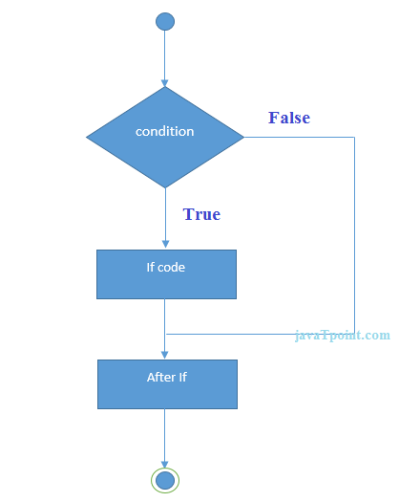
Let’s see the simple example of if statement in javascript.
- <script>
- var a=20;
- if(a>10){
- document.write("value of a is greater than 10");
- }
- </script>

Output of the above example
value of a is greater than 10

JavaScript If...else Statement
It evaluates the content whether condition is true of false. The syntax of JavaScript if-else statement is given below.
- if(expression){
- //content to be evaluated if condition is true
- }
- else{
- //content to be evaluated if condition is false
- }

Flowchart of JavaScript If...else statement
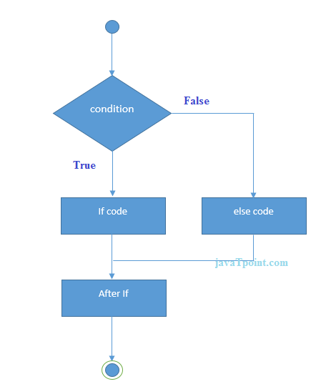
Let’s see the example of if-else statement in JavaScript to find out the even or odd number.
- <script>
- var a=20;
- if(a%2==0){
- document.write("a is even number");
- }
- else{
- document.write("a is odd number");
- }
- </script>

Output of the above example
a is even number

JavaScript If...else if statement
It evaluates the content only if expression is true from several expressions. The signature of JavaScript if else if statement is given below.
- if(expression1){
- //content to be evaluated if expression1 is true
- }
- else if(expression2){

- v//content to be evaluated if expression2 is true
- }
- else if(expression3){
- //content to be evaluated if expression3 is true
- }
- else{
- //content to be evaluated if no expression is true
- }
Let’s see the simple example of if else if statement in javascript.
- <script>
- var a=20,b=2,c=8;
- if(a>b && a>c){
- document.write("a is greater");
- }
- else if(b>a && b>c){
- document.write("b is greater");
- }
- else if(c>a && c>b){
- document.write("c is greater");
- }
- else{
- document.write("all are equal");
- }
- </script>

JavaScript Switch
The JavaScript switch statement is used to execute one code from multiple expressions. It is just like else if statement that we have learned in previous page. But it is convenient than if..else..if because it can be used with numbers, characters etc.
The signature of JavaScript switch statement is given below.
- switch(expression){
- case value1:
- code to be executed;
- break;
- case value2:
- code to be executed;
- break;
- ......

- default:
- code to be executed if above values are not matched;
- }
Let’s see the simple example of switch statement in javascript.
<script>
var grade='B';
var result;
switch(grade){
case 'A':
result="A Grade";
break;
case 'B':
result="B Grade";
break;
case 'C':
result="C Grade";
break;
default:
result="No Grade";
}
document.write(result);
</script>

Output of the above example
B Grade

The switch statement is fall-through i.e. all the cases will be evaluated if you don't use break statement.
Let’s understand the behaviour of switch statement in JavaScript.
<script>
var grade='B';
var result;
switch(grade){
case 'A':
result+=" A Grade";
case 'B':
result+=" B Grade";
case 'C':
result+=" C Grade";
default:
result+=" No Grade";
}
document.write(result);
</script>

JavaScript Loops
The JavaScript loops are used to iterate the piece of code using for, while, do while or for-in loops. It makes the code compact. It is mostly used in array.
There are four types of loops in JavaScript.
- for loop
- while loop
- do-while loop
- for-in loop

1) JavaScript For loop
The JavaScript for loop iterates the elements for the fixed number of times. It should be used if number of iteration is known. The syntax of for loop is given below.
- for (initialization; condition; increment)
- {
- code to be executed
- }
Let’s see the simple example of for loop in javascript.
- <script>
- for (i=1; i<=5; i++)
- {
- document.write(i + "<br/>")
- }
- </script>
Output:
1
2
3
4
5

2) JavaScript while loop
The JavaScript while loop iterates the elements for the infinite number of times. It should be used if number of iteration is not known. The syntax of while loop is given below.
- while (condition)
- {
- code to be executed
- }
Let’s see the simple example of while loop in javascript.
- <script>
- var i=11;
- while (i<=15)
- {
- document.write(i + "<br/>");
- i++;
- }
- </script>
Output:
11
12
13
14
15

3) JavaScript do while loop
The JavaScript do while loop iterates the elements for the infinite number of times like while loop. But, code is executed at least once whether condition is true or false. The syntax of do while loop is given below.
- do{
- code to be executed
- }while (condition);
Let’s see the simple example of do while loop in javascript.
- <script>
- var i=21;
- do{
- document.write(i + "<br/>");
- i++;
- }while (i<=25);
- </script>

JavaScript Functions
JavaScript functions are used to perform operations. We can call JavaScript function many times to reuse the code.

Advantage of JavaScript function
There are mainly two advantages of JavaScript functions.
- Code reusability: We can call a function several times so it save coding.
- Less coding: It makes our program compact. We don’t need to write many lines of code each time to perform a common task.

JavaScript Function Syntax
The syntax of declaring function is given below.
- function functionName([arg1, arg2, ...argN]){
- //code to be executed
- }
JavaScript Functions can have 0 or more arguments.

JavaScript Function Example
Let’s see the simple example of function in JavaScript that does not has arguments.
- <script>
- function msg(){
- alert("hello! this is message");
- }

- </script>

- <input type="button" onclick="msg()" value="call function"/>

Output of the above example

JavaScript Function Arguments
We can call function by passing arguments. Let’s see the example of function that has one argument.
- <script>
- function getcube(number){
- alert(number*number*number);
- }
- </script>
- <form>
- <input type="button" value="click" onclick="getcube(4)"/>
- </form>

Output of the above example
Top of Form
Bottom of Form

Function with Return Value
We can call function that returns a value and use it in our program. Let’s see the example of function that returns value.
- <script>
- function getInfo(){
- return "hello ! How r u?";
- }
- </script>
- <script>
- document.write(getInfo());
- </script>

Output of the above example
hello ! How r u?

JavaScript Function Object
In JavaScript, the purpose of Function constructor is to create a new Function object. It executes the code globally. However, if we call the constructor directly, a function is created dynamically but in an unsecured way.

Syntax
- new Function ([arg1[, arg2[, ....argn]],] functionBody)

Parameter
arg1, arg2, .... , argn - It represents the argument used by function.
functionBody - It represents the function definition.

JavaScript Function Object Examples

Example 1
Let's see an example to display the sum of given numbers.
- <script>
- var add=new Function("num1","num2","return num1+num2");
- document.writeln(add(2,5));
- </script>
Test it Now
Output:
7

Example 2
Let's see an example to display the power of provided value.
- <script>
- var pow=new Function("num1","num2","return Math.pow(num1,num2)");
- document.writeln(pow(2,3));
- </script>

JavaScript Objects
A javaScript object is an entity having state and behavior (properties and method). For example: car, pen, bike, chair, glass, keyboard, monitor etc.
JavaScript is an object-based language. Everything is an object in JavaScript.
JavaScript is template based not class based. Here, we don't create class to get the object. But, we direct create objects.

Creating Objects in JavaScript
There are 3 ways to create objects.
- By object literal
- By creating instance of Object directly (using new keyword)
- By using an object constructor (using new keyword)

1) JavaScript Object by object literal
The syntax of creating object using object literal is given below:
- object={property1:value1,property2:value2.....propertyN:valueN}
As you can see, property and value is separated by : (colon).
Let’s see the simple example of creating object in JavaScript.
- <script>
- emp={id:102,name:"Shyam Kumar",salary:40000}
- document.write(emp.id+" "+emp.name+" "+emp.salary);
- </script>

Output of the above example
102 Shyam Kumar 40000

2) By creating instance of Object
The syntax of creating object directly is given below:
- var objectname=new Object();
Here, new keyword is used to create object.
Let’s see the example of creating object directly.
<script>
var emp=new Object();
emp.id=101;
emp.name="Ravi Malik";
emp.salary=50000;
document.write(emp.id+" "+emp.name+" "+emp.salary);
</script>

Output of the above example
101 Ravi 50000

3) By using an Object constructor
Here, you need to create function with arguments. Each argument value can be assigned in the current object by using this keyword.
The this keyword refers to the current object.
The example of creating object by object constructor is given below.
- <script>
- function emp(id,name,salary){
- this.id=id;
- this.name=name;
- this.salary=salary;
- }
- e=new emp(103,"Vimal Jaiswal",30000);

- document.write(e.id+" "+e.name+" "+e.salary);
- </script>

Output of the above example
103 Vimal Jaiswal 30000

Defining method in JavaScript Object
We can define method in JavaScript object. But before defining method, we need to add property in the function with same name as method.
The example of defining method in object is given below.
- <script>
- function emp(id,name,salary){
- this.id=id;
- this.name=name;
- this.salary=salary;

- this.changeSalary=changeSalary;
- function changeSalary(otherSalary){
- this.salary=otherSalary;
- }
- }
- e=new emp(103,"Sonoo Jaiswal",30000);
- document.write(e.id+" "+e.name+" "+e.salary);
- e.changeSalary(45000);
- document.write("<br>"+e.id+" "+e.name+" "+e.salary);
- </script>

Output of the above example
103 Sonoo Jaiswal 30000
103 Sonoo Jaiswal 45000

JavaScript Array
JavaScript array is an object that represents a collection of similar type of elements.
There are 3 ways to construct array in JavaScript
- By array literal
- By creating instance of Array directly (using new keyword)
- By using an Array constructor (using new keyword)

1) JavaScript array literal
The syntax of creating array using array literal is given below:
- var arrayname=[value1,value2.....valueN];
As you can see, values are contained inside [ ] and separated by , (comma).
15.6M
246
Triggers in SQL (Hindi)
Let's see the simple example of creating and using array in JavaScript.
<script>
var emp=["Sonoo","Vimal","Ratan"];
for (i=0;i<emp.length;i++){
document.write(emp[i] + "<br/>");
}
</script>

The .length property returns the length of an array.
Output of the above example
Sonoo
Vimal
Ratan

2) JavaScript Array directly (new keyword)
The syntax of creating array directly is given below:
- var arrayname=new Array();
Here, new keyword is used to create instance of array.
Let's see the example of creating array directly.
- <script>
- var i;
- var emp = new Array();
- emp[0] = "Arun";
- emp[1] = "Varun";
- emp[2] = "John";

- for (i=0;i<emp.length;i++){
- document.write(emp[i] + "<br>");
- }
- </script>
Output of the above example
Arun
Varun
John

3) JavaScript array constructor (new keyword)
Here, you need to create instance of array by passing arguments in constructor so that we don't have to provide value explicitly.
The example of creating object by array constructor is given below.
- <script>
- var emp=new Array("Jai","Vijay","Smith");
- for (i=0;i<emp.length;i++){
- document.write(emp[i] + "<br>");
- }
- </script>

Output of the above example
Jai
Vijay
Smith

JavaScript Array Methods

JavaScript Array concat() Method
The JavaScript array concat() method combines two or more arrays and returns a new string. This method doesn't make any change in the original array.

Syntax
The concat() method is represented by the following syntax:
- array.concat(arr1,arr2,....,arrn)

Parameter
arr1,arr2,....,arrn - It represent the arrays to be combined.

Return
A new array object that represents a joined array.

JavaScript Array concat() Method Example
Let's see some examples of concat() method.

Example 1
Here, we will print the combination of two arrays.
<script>
var arr1=["C","C++","Python"];
var arr2=["Java","JavaScript","Android"];
var result=arr1.concat(arr2);
document.writeln(result);
</script>
Output:
C,C++,Python,Java,JavaScript,Android

Example 2
Here, we will print the combination of three arrays.
- <script>
- var arr1=["C","C++","Python"];
- var arr2=["Java","JavaScript","Android"];
- var arr3=["Ruby","Kotlin"];
- var result=arr1.concat(arr2,arr3);
- document.writeln(result);
- </script>

JavaScript Array isArray() Method
The isArray() method is used to test whether the value passed is an array. If it finds the passed value is an array, it returns True. Otherwise, it returns False.

Syntax
- Array.isArray(obj_value);

Parameter
obj_value: It is the value of the object which is passed for determining whether it is an array or not.

Return
It returns either false or true, depending on the test.

JavaScript Array isArray() Method Example
Let's see the below implementations and determine if the value is an array.
Example1
This example shows a basic implementation of isArray() method.
<html>
<head> <h5> JavaScript Array Methods </h5> </head>
<body>
<script>
document.write(Array.isArray(1,2,3,4)); //Testing the passed values.
</script>
</body>
</html>

JavaScript Array reverse() method
The JavaScript array reverse() method changes the sequence of elements of the given array and returns the reverse sequence. In other words, the arrays last element becomes first and the first element becomes the last. This method also made the changes in the original array.

Syntax
The reverse() method is represented by the following syntax:
- array.reverse()

Return
The original array elements in rev erse order.

JavaScript Array reverse() method example
Let's see an example to reverse the sequence of elements of the array.

Example
<script>
var arr=["AngulaJS","Node.js","JQuery"];
var rev=arr.reverse();
document.writeln(rev);
</script>

JavaScript Array sort() method
The JavaScript array sort() method is used to arrange the array elements in some order. By default, sort() method follows the ascending order.

Syntax
The sort() method is represented by the following syntax:
- array.sort(compareFunction)

Parameter
compareFunction - It is optional. It represents a function that provides an alternative sort order.

Return
An array of sorted elements

JavaScript Array sort() method example
Here, we will understand sort() method through various examples.

Example 1
Let's see a simple example to sort the array of string elements.
<script>
var arr=["AngularJS","Node.js","JQuery","Bootstrap"]
var result=arr.sort();
document.writeln(result);
</script>

Output:
AngularJS,Bootstrap,JQuery,Node.js

Example 2
Let's see a simple example to sort the array of integer elements.
- <script>
var arr=[2,4,1,8,5];
var result=arr.sort();
document.writeln(result);
</script>
Output:
1,2,4,5,8

Example 3
Let's see an example to arrange the elements in ascending order using function.
- <script>
- var arr=[2,4,1,8,5];
- var result=arr.sort(function compare(a,b)
- {
- return a-b;
- });

- document.writeln(result);
- </script>

JavaScript String
The JavaScript string is an object that represents a sequence of characters.
There are 2 ways to create string in JavaScript
- By string literal
- By string object (using new keyword)

1) By string literal
The string literal is created using double quotes. The syntax of creating string using string literal is given below:
- var stringname="string value";
Let's see the simple example of creating string literal.
34.6M
804
- <script>
- var str="This is string literal";
- document.write(str);
- </script>

Output:
This is string literal

2) By string object (using new keyword)
The syntax of creating string object using new keyword is given below:
- var stringname=new String("string literal");
Here, new keyword is used to create instance of string.
Let's see the example of creating string in JavaScript by new keyword.
<script>
var stringname=new String("hello javascript string");
document.write(stringname);
</script>

Output:
hello javascript string

JavaScript String Methods
Let's see the list of JavaScript string methods with examples.
Methods | Description
charAt() | It provides the char value present at the specified index.
charCodeAt() | It provides the Unicode value of a character present at the specified index.
concat() | It provides a combination of two or more strings.
indexOf() | It provides the position of a char value present in the given string.
lastIndexOf() | It provides the position of a char value present in the given string by searching a character from the last position.
search() | It searches a specified regular expression in a given string and returns its position if a match occurs.
match() | It searches a specified regular expression in a given string and returns that regular expression if a match occurs.
replace() | It replaces a given string with the specified replacement.
substr() | It is used to fetch the part of the given string on the basis of the specified starting position and length.
substring() | It is used to fetch the part of the given string on the basis of the specified index.
slice() | It is used to fetch the part of the given string. It allows us to assign positive as well negative index.
toLowerCase() | It converts the given string into lowercase letter.
toLocaleLowerCase() | It converts the given string into lowercase letter on the basis of host?s current locale.
toUpperCase() | It converts the given string into uppercase letter.
toLocaleUpperCase() | It converts the given string into uppercase letter on the basis of host?s current locale.
toString() | It provides a string representing the particular object.
valueOf() | It provides the primitive value of string object.
split() | It splits a string into substring array, then returns that newly created array.
trim() | It trims the white space from the left and right side of the string.

1) JavaScript String charAt(index) Method
The JavaScript String charAt() method returns the character at the given index.
<script>
var str="javascript";
document.write(str.charAt(2));
</script>
Output:
v

2) JavaScript String concat(str) Method
The JavaScript String concat(str) method concatenates or joins two strings.
<script>
var s1="javascript ";
var s2="concat example";
var s3=s1.concat(s2);
document.write(s3);
</script>

Output:
javascript concat example

3) JavaScript String indexOf(str) Method
The JavaScript String indexOf(str) method returns the index position of the given string.
- <script>
- var s1="javascript from java indexof";
- var n=s1.indexOf("from");
- document.write(n);
- </script>

Output:
11

4) JavaScript String lastIndexOf(str) Method
The JavaScript String lastIndexOf(str) method returns the last index position of the given string.
- <script>
- var s1="javascript from java indexof";
- var n=s1.lastIndexOf("java");
- document.write(n);
- </script>
Output:
16

5) JavaScript String toLowerCase() Method
The JavaScript String toLowerCase() method returns the given string in lowercase letters.
<script>
var s1="JavaScript toLowerCase Example";
var s2=s1.toLowerCase();
document.write(s2);
</script>

Output:
javascript tolowercase example

6) JavaScript String toUpperCase() Method
The JavaScript String toUpperCase() method returns the given string in uppercase letters.
<script>
var s1="JavaScript toUpperCase Example";
var s2=s1.toUpperCase();
document.write(s2);
</script>

Output:
JAVASCRIPT TOUPPERCASE EXAMPLE

7) JavaScript String slice(beginIndex, endIndex) Method
The JavaScript String slice(beginIndex, endIndex) method returns the parts of string from given beginIndex to endIndex. In slice() method, beginIndex is inclusive and endIndex is exclusive.
<script>
var s1="abcdefgh";
var s2=s1.slice(2,5);
document.write(s2);
</script>
Output:
cde

8) JavaScript String trim() Method
The JavaScript String trim() method removes leading and trailing whitespaces from the string.
<script>
var s1=" javascript trim ";
var s2=s1.trim();
document.write(s2);
</script>

Output:
javascript trim

9) JavaScript String split() Method
<script>
var str="This is Java website";
document.write(str.split(" ")); //splits the given string.
</script>

JavaScript Date Object
The JavaScript date object can be used to get year, month and day. You can display a timer on the webpage by the help of JavaScript date object.
You can use different Date constructors to create date object. It provides methods to get and set day, month, year, hour, minute and seconds.

Constructor
You can use 4 variant of Date constructor to create date object.
- Date()
- Date(milliseconds)
- Date(dateString)
- Date(year, month, day, hours, minutes, seconds, milliseconds)

JavaScript Date Methods
Let's see the list of JavaScript date methods with their description.

JavaScript Date Example
Let's see the simple example to print date object. It prints date and time both.
Current Date and Time: <span id="txt"></span>
<script>
var today=new Date();
document.getElementById('txt').innerHTML=today;
</script>

Output:
Current Date and Time: Tue Mar 01 2022 15:41:16 GMT+0530 (India Standard Time)

Let's see another code to print date/month/year.
<script>
var date=new Date();
var day=date.getDate();
var month=date.getMonth()+1;
var year=date.getFullYear();
document.write("<br>Date is: "+day+"/"+month+"/"+year);
</script>
Output:
Date is: 1/3/2022

JavaScript Current Time Example
Let's see the simple example to print current time of system.
Current Time: <span id="txt"></span>
<script>
var today=new Date();
var h=today.getHours();
var m=today.getMinutes();
var s=today.getSeconds();
document.getElementById('txt').innerHTML=h+":"+m+":"+s;
</script>
Output:
Current Time: 15:41:16

JavaScript Digital Clock Example
Let's see the simple example to display digital clock using JavaScript date object.
There are two ways to set interval in JavaScript: by setTimeout() or setInterval() method.
Current Time: <span id="txt"></span>
<script>
window.onload=function(){getTime();}
function getTime(){
var today=new Date();
var h=today.getHours();
var m=today.getMinutes();
var s=today.getSeconds();
// add a zero in front of numbers<10
m=checkTime(m);
s=checkTime(s);
document.getElementById('txt').innerHTML=h+":"+m+":"+s;
setTimeout(function(){getTime()},1000);
}
//setInterval("getTime()",1000);//another way
function checkTime(i){
if (i<10){
i="0" + i;
}
return i;
}
</script>

JavaScript Math
The JavaScript math object provides several constants and methods to perform mathematical operation. Unlike date object, it doesn't have constructors.

JavaScript Math Methods
Let's see the list of JavaScript Math methods with description.

Math.sqrt(n)
The JavaScript math.sqrt(n) method returns the square root of the given number.
Square Root of 17 is: <span id="p1"></span>
<script>
document.getElementById('p1').innerHTML=Math.sqrt(17);
</script>

Output:
34.6M
804
OOPs Concepts in Java
Square Root of 17 is: 4.123105625617661

Math.random()
The JavaScript math.random() method returns the random number between 0 to 1.
Random Number is: <span id="p2"></span>
<script>
document.getElementById('p2').innerHTML=Math.random();
</script>

Output:
Random Number is: 0.5258351359519986

Math.pow(m,n)
The JavaScript math.pow(m,n) method returns the m to the power of n that is m^{n}.
- 3 to the power of 4 is: <span id="p3"></span>
- <script>
- document.getElementById('p3').innerHTML=Math.pow(3,4);
- </script>

Output:
3 to the power of 4 is: 81

Math.floor(n)
The JavaScript math.floor(n) method returns the lowest integer for the given number. For example 3 for 3.7, 5 for 5.9 etc.
Floor of 4.6 is: <span id="p4"></span>
<script>
document.getElementById('p4').innerHTML=Math.floor(4.6);
</script>
Output:
Floor of 4.6 is: 4

Math.ceil(n)
The JavaScript math.ceil(n) method returns the largest integer for the given number. For example 4 for 3.7, 6 for 5.9 etc.
- Ceil of 4.6 is: <span id="p5"></span>
- <script>
- document.getElementById('p5').innerHTML=Math.ceil(4.6);
- </script>

Output:
Ceil of 4.6 is: 5

Math.round(n)
The JavaScript math.round(n) method returns the rounded integer nearest for the given number. If fractional part is equal or greater than 0.5, it goes to upper value 1 otherwise lower value 0. For example 4 for 3.7, 3 for 3.3, 6 for 5.9 etc.
Round of 4.3 is: <span id="p6"></span><br>
Round of 4.7 is: <span id="p7"></span>
<script>
document.getElementById('p6').innerHTML=Math.round(4.3);
document.getElementById('p7').innerHTML=Math.round(4.7);
</script>

Output:
Round of 4.3 is: 4
Round of 4.7 is: 5

Math.abs(n)
The JavaScript math.abs(n) method returns the absolute value for the given number. For example 4 for -4, 6.6 for -6.6 etc.
Absolute value of -4 is: <span id="p8"></span>
<script>
document.getElementById('p8').innerHTML=Math.abs(-4);
</script>

JavaScript Number Object
The JavaScript number object enables you to represent a numeric value. It may be integer or floating-point. JavaScript number object follows IEEE standard to represent the floating-point numbers.
By the help of Number() constructor, you can create number object in JavaScript. For example:
- var n=new Number(value);
If value can't be converted to number, it returns NaN(Not a Number) that can be checked by isNaN() method.
You can direct assign a number to a variable also. For example:
var x=102;//integer value
var y=102.7;//floating point value
var z=13e4;//exponent value, output: 130000
var n=new Number(16);//integer value by number object

Output:
102 102.7 130000 16

JavaScript Number Constants
Let's see the list of JavaScript number constants with description.
Constant | Description
MIN_VALUE | returns the largest minimum value.
MAX_VALUE | returns the largest maximum value.
POSITIVE_INFINITY | returns positive infinity, overflow value.
NEGATIVE_INFINITY | returns negative infinity, overflow value.
NaN | represents "Not a Number" value.

JavaScript Boolean
JavaScript Boolean is an object that represents value in two states: true or false. You can create the JavaScript Boolean object by Boolean() constructor as given below.
- Boolean b=new Boolean(value);
The default value of JavaScript Boolean object is false.

JavaScript Boolean Example
<script>
document.write(10<20);//true
document.write(10<5);//false
</script>

JavaScript Boolean Properties
Property | Description
Constructor | returns the reference of Boolean function that created Boolean object.
Prototype | enables you to add properties and methods in Boolean prototype.

JavaScript Boolean Methods
Method | Description
toSource() | returns the source of Boolean object as a string.
toString() | converts Boolean into String.
valueOf() | converts other type into Boolean.

Browser Object Model
The Browser Object Model (BOM) is used to interact with the browser.
The default object of browser is window means you can call all the functions of window by specifying window or directly. For example:
- window.alert("hello java");
is same as:
- alert("hello java");
You can use a lot of properties (other objects) defined underneath the window object like document, history, screen, navigator, location, innerHeight, innerWidth,

Note: The document object represents an html document. It forms DOM (Document Object Model).
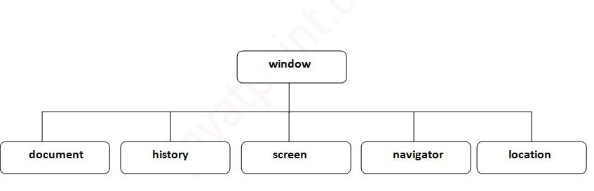

Window Object
The window object represents a window in browser. An object of window is created automatically by the browser.
Window is the object of browser, it is not the object of javascript. The javascript objects are string, array, date etc.

Note: if html document contains frame or iframe, browser creates additional window objects for each frame.

Methods of window object
The important methods of window object are as follows:
Method | Description
alert() | displays the alert box containing message with ok button.
confirm() | displays the confirm dialog box containing message with ok and cancel button.
prompt() | displays a dialog box to get input from the user.
open() | opens the new window.
close() | closes the current window.
setTimeout() | performs action after specified time like calling function, evaluating expressions etc.

Example of alert() in javascript
It displays alert dialog box. It has message and ok button.
<script type="text/javascript">
function msg(){
alert("Hello Alert Box");
}
</script>
<input type="button" value="click" onclick="msg()"/>

Output of the above example

Example of confirm() in javascript
It displays the confirm dialog box. It has message with ok and cancel buttons.
- <script type="text/javascript">
- function msg(){
- var v= confirm("Are u sure?");
- if(v==true){
- alert("ok");
- }
- else{
- alert("cancel");
- }

- }
- </script>

- <input type="button" value="delete record" onclick="msg()"/>

Output of the above example

Example of prompt() in javascript
It displays prompt dialog box for input. It has message and textfield.
- <script type="text/javascript">
- function msg(){
- var v= prompt("Who are you?");
- alert("I am "+v);

- }
- </script>

- <input type="button" value="click" onclick="msg()"/>

Output of the above example

Example of open() in javascript
It displays the content in a new window.
- <script type="text/javascript">
- function msg(){
- open("http://www.gmail.com");
- }
- </script>
- <input type="button" value="gmail" onclick="msg()"/>

Output of the above example

Example of setTimeout() in javascript
It performs its task after the given milliseconds.
- <script type="text/javascript">
- function msg(){
- setTimeout(
- function(){
- alert("Welcome to Java after 2 seconds")
- },2000);

- }
- </script>

- <input type="button" value="click" onclick="msg()"/>

JavaScript History Object
The JavaScript history object represents an array of URLs visited by the user. By using this object, you can load previous, forward or any particular page.
The history object is the window property, so it can be accessed by:
- window.history
Or,
- history

Property of JavaScript history object
There are only 1 property of history object.
No. | Property | Description
1 | Length | returns the length of the history URLs.

Methods of JavaScript history object
There are only 3 methods of history object.
No. | Method | Description
1 | forward() | loads the next page.
2 | back() | loads the previous page.
3 | go() | loads the given page number.

Example of history object
Let’s see the different usage of history object.
- history.back();//for previous page
- history.forward();//for next page
- history.go(2);//for next 2nd page
- history.go(-2);//for previous 2nd page

JavaScript Navigator Object
The JavaScript navigator object is used for browser detection. It can be used to get browser information such as appName, appCodeName, userAgent etc.
The navigator object is the window property, so it can be accessed by:
- window.navigator
Or,
- navigator

Property of JavaScript navigator object
There are many properties of navigator object that returns information of the browser.
No. | Property | Description
1 | appName | returns the name
2 | appVersion | returns the version
3 | appCodeName | returns the code name
4 | cookieEnabled | returns true if cookie is enabled otherwise false
5 | userAgent | returns the user agent
6 | Language | returns the language. It is supported in Netscape and Firefox only.
7 | userLanguage | returns the user language. It is supported in IE only.
8 | Plugins | returns the plugins. It is supported in Netscape and Firefox only.
9 | systemLanguage | returns the system language. It is supported in IE only.
10 | mimeTypes[] | returns the array of mime type. It is supported in Netscape and Firefox only.
11 | Platform | returns the platform e.g. Win32.
12 | Online | returns true if browser is online otherwise false.

Methods of JavaScript navigator object
The methods of navigator object are given below.
No. | Method | Description
1 | javaEnabled() | checks if java is enabled.
2 | taintEnabled() | checks if taint is enabled. It is deprecated since JavaScript 1.2.

Example of navigator object
Let’s see the different usage of history object.
- <script>
- document.writeln("<br/>navigator.appCodeName: "+navigator.appCodeName);
- document.writeln("<br/>navigator.appName: "+navigator.appName);
- document.writeln("<br/>navigator.appVersion: "+navigator.appVersion);
- document.writeln("<br/>navigator.cookieEnabled: "+navigator.cookieEnabled);
- document.writeln("<br/>navigator.language: "+navigator.language);
- document.writeln("<br/>navigator.userAgent: "+navigator.userAgent);
- document.writeln("<br/>navigator.platform: "+navigator.platform);
- document.writeln("<br/>navigator.onLine: "+navigator.onLine);
- </script>

navigator.appCodeName: Mozilla
navigator.appName: Netscape
navigator.appVersion: 5.0 (Windows NT 6.2; WOW64) AppleWebKit/537.36
(KHTML, like Gecko) Chrome/37.0.2062.124 Safari/537.36
navigator.cookieEnabled: true
navigator.language: en-US
navigator.userAgent: Mozilla/5.0 (Windows NT 6.2; WOW64) AppleWebKit/537.36
(KHTML, like Gecko) Chrome/37.0.2062.124 Safari/537.36
navigator.platform: Win32
navigator.onLine: true

JavaScript Screen Object
The JavaScript screen object holds information of browser screen. It can be used to display screen width, height, colorDepth, pixelDepth etc.
The navigator object is the window property, so it can be accessed by:
- window.screen
Or,
- screen

Property of JavaScript Screen Object
There are many properties of screen object that returns information of the browser.
No. | Property | Description
1 | Width | returns the width of the screen
2 | Height | returns the height of the screen
3 | availWidth | returns the available width
4 | availHeight | returns the available height
5 | colorDepth | returns the color depth
6 | pixelDepth | returns the pixel depth.

Example of JavaScript Screen Object
Let’s see the different usage of screen object.
- <script>
- document.writeln("<br/>screen.width: "+screen.width);
- document.writeln("<br/>screen.height: "+screen.height);
- document.writeln("<br/>screen.availWidth: "+screen.availWidth);
- document.writeln("<br/>screen.availHeight: "+screen.availHeight);
- document.writeln("<br/>screen.colorDepth: "+screen.colorDepth);
- document.writeln("<br/>screen.pixelDepth: "+screen.pixelDepth);
- </script>

screen.width: 1366
screen.height: 768
screen.availWidth: 1366
screen.availHeight: 728
screen.colorDepth: 24
screen.pixelDepth: 24

Document Object Model
The document object represents the whole html document.
When html document is loaded in the browser, it becomes a document object. It is the root element that represents the html document. It has properties and methods. By the help of document object, we can add dynamic content to our web page.
As mentioned earlier, it is the object of window. So
- window.document
Is same as
- document
According to W3C - "The W3C Document Object Model (DOM) is a platform and language-neutral interface that allows programs and scripts to dynamically access and update the content, structure, and style of a document."

Properties of document object
Let's see the properties of document object that can be accessed and modified by the document object. 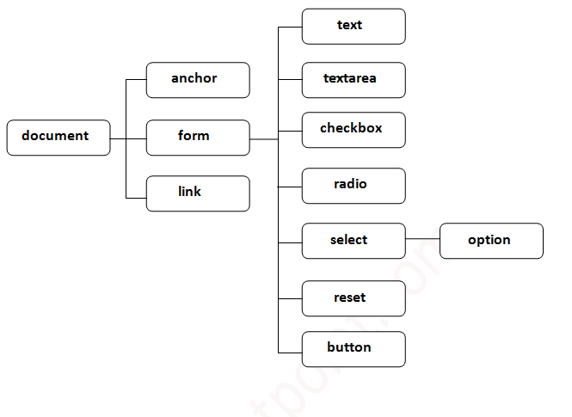

Methods of document object
We can access and change the contents of document by its methods.
The important methods of document object are as follows:
Method | Description
write("string") | writes the given string on the doucment.
writeln("string") | writes the given string on the doucment with newline character at the end.
getElementById() | returns the element having the given id value.
getElementsByName() | returns all the elements having the given name value.
getElementsByTagName() | returns all the elements having the given tag name.
getElementsByClassName() | returns all the elements having the given class name.

Accessing field value by document object
In this example, we are going to get the value of input text by user. Here, we are using document.form1.name.value to get the value of name field.
Here, document is the root element that represents the html document.
form1 is the name of the form.
name is the attribute name of the input text.
value is the property, that returns the value of the input text.
Let's see the simple example of document object that prints name with welcome message.
<script type="text/javascript">
function printvalue(){
var name=document.form1.name.value;
alert("Welcome: "+name);
}
</script>

<form name="form1">
Enter Name:<input type="text" name="name"/>
<input type="button" onclick="printvalue()" value="print name"/>
</form>

Javascript - document.getElementById() method
The document.getElementById() method returns the element of specified id.
In the previous page, we have used document.form1.name.value to get the value of the input value. Instead of this, we can use document.getElementById() method to get value of the input text. But we need to define id for the input field.
Let's see the simple example of document.getElementById() method that prints cube of the given number.
<script type="text/javascript">
function getcube(){
var number=document.getElementById("number").value;
alert(number*number*number);
}
</script>
<form>
Enter No:<input type="text" id="number" name="number"/><br/>
<input type="button" value="cube" onclick="getcube()"/>
</form>

Javascript - document.getElementsByName() method
- getElementsByName() method
- Example of getElementsByName()
The document.getElementsByName() method returns all the element of specified name.
The syntax of the getElementsByName() method is given below:
- document.getElementsByName("name")
Here, name is required.

Example of document.getElementsByName() method
In this example, we going to count total number of genders. Here, we are using getElementsByName() method to get all the genders.
<script type="text/javascript">
function totalelements()
{
var allgenders=document.getElementsByName("gender");
alert("Total Genders:"+allgenders.length);
}
</script>
<form>
Male:<input type="radio" name="gender" value="male">
Female:<input type="radio" name="gender" value="female">

<input type="button" onclick="totalelements()" value="Total Genders">
</form>

Javascript - document.getElementsByTagName() method
- getElementsByTagName() method
- Example of getElementsByTagName()
The document.getElementsByTagName() method returns all the element of specified tag name.
The syntax of the getElementsByTagName() method is given below:
- document.getElementsByTagName("name")
Here, name is required.

Example of document.getElementsByTagName() method
In this example, we going to count total number of paragraphs used in the document. To do this, we have called the document.getElementsByTagName("p") method that returns the total paragraphs.
- <script type="text/javascript">
- function countpara(){
- var totalpara=document.getElementsByTagName("p");
- alert("total p tags are: "+totalpara.length);

- }
- </script>
- <p>This is a pragraph</p>
- <p>Here we are going to count total number of paragraphs by getElementByTagName() method.</p>
- <p>Let's see the simple example</p>
- <button onclick="countpara()">count paragraph</button>

Javascript - innerHTML
The innerHTML property can be used to write the dynamic html on the html document.
It is used mostly in the web pages to generate the dynamic html such as registration form, comment form, links etc.

Example of innerHTML property
In this example, we are going to create the html form when user clicks on the button.
In this example, we are dynamically writing the html form inside the div name having the id mylocation. We are identifing this position by calling the document.getElementById() method.
<script type="text/javascript" >
function showcommentform() {
var data="Name:<input type='text' name='name'><br>Comment:<br><textarea rows='5' cols='80'></textarea>
<br><input type='submit' value='Post Comment'>";
document.getElementById('mylocation').innerHTML=data;
}
</script>
<form name="myForm">
<input type="button" value="comment" onclick="showcommentform()">
<div id="mylocation"></div>
</form>

Javascript - innerText

The innerText property can be used to write the dynamic text on the html document. Here, text will not be interpreted as html text but a normal text.
It is used mostly in the web pages to generate the dynamic content such as writing the validation message, password strength etc.

Javascript innerText Example
In this example, we are going to display the password strength when releases the key after press.
- <script type="text/javascript" >
- function validate() {
- var msg;
- if(document.myForm.userPass.value.length>5){
- msg="good";
- }
- else{
- msg="poor";
- }
- document.getElementById('mylocation').innerText=msg;
- }

- </script>
- <form name="myForm">
- <input type="password" value="" name="userPass" onkeyup="validate()">
- Strength:<span id="mylocation">no strength</span>
- </form>

JavaScript Form Validation
It is important to validate the form submitted by the user because it can have inappropriate values. So, validation is must to authenticate user.
JavaScript provides facility to validate the form on the client-side so data processing will be faster than server-side validation. Most of the web developers prefer JavaScript form validation.
Through JavaScript, we can validate name, password, email, date, mobile numbers and more fields.

JavaScript Form Validation Example
In this example, we are going to validate the name and password. The name can’t be empty and password can’t be less than 6 characters long.
Here, we are validating the form on form submit. The user will not be forwarded to the next page until given values are correct.
- <script>
- function validateform(){
- var name=document.myform.name.value;
- var password=document.myform.password.value;

- if (name==null || name==""){
- alert("Name can't be blank");
- return false;
- }else if(password.length<6){
- alert("Password must be at least 6 characters long.");
- return false;
- }
- }
- </script>
- <body>
- <form name="myform" method="post" action="" onsubmit="return validateform()" >
- Name: <input type="text" name="name"><br/>
- Password: <input type="password" name="password"><br/>
- <input type="submit" value="register">
- </form>

JavaScript Retype Password Validation
- <script type="text/javascript">
- function matchpass(){
- var firstpassword=document.f1.password.value;
- var secondpassword=document.f1.password2.value;

- if(firstpassword==secondpassword){
- return true;
- }
- else{
- alert("password must be same!");
- return false;
- }
- }
- </script>

- <form name="f1" action="" onsubmit="return matchpass()">
- Password:<input type="password" name="password" /><br/>
- Re-enter Password:<input type="password" name="password2"/><br/>
- <input type="submit">
- </form>

JavaScript Number Validation
Let's validate the textfield for numeric value only. Here, we are using isNaN() function.
<script>
function validate(){
var num=document.myform.num.value;
if (isNaN(num)){
document.getElementById("numloc").innerHTML="Enter Numeric value only";
return false;
}else{
return true;
}
}
</script>
<form name="myform" onsubmit="return validate()" >
Number: <input type="text" name="num"><span id="numloc"></span><br/>
<input type="submit" value="submit">
</form>

JavaScript validation with image
Let’s see an interactive JavaScript form validation example that displays correct and incorrect image if input is correct or incorrect.
- <script>
- function validate(){
- var name=document.f1.name.value;
- var password=document.f1.password.value;
- var status=false;

- if(name.length<1){
- document.getElementById("nameloc").innerHTML=
- " <img src='unchecked.gif'/> Please enter your name";
- status=false;
- }else{
- document.getElementById("nameloc").innerHTML=" <img src='checked.gif'/>";
- status=true;
- }
- if(password.length<6){
- document.getElementById("passwordloc").innerHTML=
- " <img src='unchecked.gif'/> Password must be at least 6 char long";
- status=false;
- }else{
- document.getElementById("passwordloc").innerHTML=" <img src='checked.gif'/>";
- }
- return status;
- }
- </script>

- <form name="f1" action="#" onsubmit="return validate()">
- <table>
- <tr><td>Enter Name:</td><td><input type="text" name="name"/>
- <span id="nameloc"></span></td></tr>
- <tr><td>Enter Password:</td><td><input type="password" name="password"/>
- <span id="passwordloc"></span></td></tr>
- <tr><td colspan="2"><input type="submit" value="register"/></td></tr>
- </table>
- </form>

Output:
Top of Form
Enter Name:
Enter Password:
Bottom of Form

JavaScript email validation
We can validate the email by the help of JavaScript.
There are many criteria that need to be follow to validate the email id such as:
- email id must contain the @ and . character
- There must be at least one character before and after the @.
- There must be at least two characters after . (dot).
Let's see the simple example to validate the email field.
- <script>
- function validateemail()
- {
- var x=document.myform.email.value;
- var atposition=x.indexOf("@");
- var dotposition=x.lastIndexOf(".");
- if (atposition<1 || dotposition<atposition+2 || dotposition+2>=x.length){
- alert("Please enter a valid e-mail address \n atpostion:"+atposition+"\n dotposition:"+dotposition);
- return false;
- }
- }
- </script>
- <body>
- <form name="myform" method="post" action="#" onsubmit="return validateemail();">
- Email: <input type="text" name="email"><br/>

- <input type="submit" value="register">
- </form>

JavaScript Classes
In JavaScript, classes are the special type of functions. We can define the class just like function declarations and function expressions.
The JavaScript class contains various class members within a body including methods or constructor. The class is executed in strict mode. So, the code containing the silent error or mistake throws an error.
The class syntax contains two components:
- Class declarations
- Class expressions

Class Declarations
A class can be defined by using a class declaration. A class keyword is used to declare a class with any particular name. According to JavaScript naming conventions, the name of the class always starts with an uppercase letter.
35.1M
690
HTML Tutorial
Next
Stay

Class Declarations Example
Let's see a simple example of declaring the class.

- <script>
- //Declaring class
- class Employee
- {
- //Initializing an object
- constructor(id,name)
- {
- this.id=id;
- this.name=name;
- }
- //Declaring method
- detail()
- {
- document.writeln(this.id+" "+this.name+"<br>")
- }
- }
- //passing object to a variable
- var e1=new Employee(101,"Martin Roy");
- var e2=new Employee(102,"Duke William");
- e1.detail(); //calling method
- e2.detail();
- </script>

Output:
101 Martin Roy
102 Duke William

Class Declarations Example: Hoisting
Unlike function declaration, the class declaration is not a part of JavaScript hoisting. So, it is required to declare the class before invoking it.
Let's see an example.

- <script>
- //Here, we are invoking the class before declaring it.
- var e1=new Employee(101,"Martin Roy");
- var e2=new Employee(102,"Duke William");
- e1.detail(); //calling method
- e2.detail();

- //Declaring class
- class Employee
- {
- //Initializing an object
- constructor(id,name)
- {
- this.id=id;
- this.name=name;
- }
- detail()
- {
- document.writeln(this.id+" "+this.name+"<br>")
- }
- }
- </script>

Output:
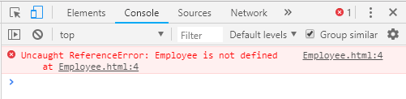

Class Declarations Example: Re-declaring Class
A class can be declared once only. If we try to declare class more than one time, it throws an error.
Let's see an example.

<script>
//Declaring class
class Employee
{
//Initializing an object
constructor(id,name)
{
this.id=id;
this.name=name;
}
detail()
{
document.writeln(this.id+" "+this.name+"<br>")
}
}
//passing object to a variable
var e1=new Employee(101,"Martin Roy");
var e2=new Employee(102,"Duke William");
e1.detail(); //calling method
e2.detail();
//Re-declaring class
class Employee
{
}
</script>

Output:
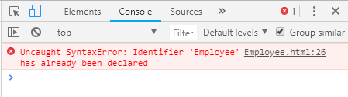

Class expressions
Another way to define a class is by using a class expression. Here, it is not mandatory to assign the name of the class. So, the class expression can be named or unnamed. The class expression allows us to fetch the class name. However, this will not be possible with class declaration.

Unnamed Class Expression
The class can be expressed without assigning any name to it.
Let's see an example.

- <script>
- var emp = class {
- constructor(id, name) {
- this.id = id;
- this.name = name;
- }
- };
- document.writeln(emp.name);
- </script>

Output:
emp

Class Expression Example: Re-declaring Class
Unlike class declaration, the class expression allows us to re-declare the same class. So, if we try to declare the class more than one time, it throws an error.

- <script>
- //Declaring class
- var emp=class
- {
- //Initializing an object
- constructor(id,name)
- {
- this.id=id;
- this.name=name;
- }
- //Declaring method
- detail()
- {
- document.writeln(this.id+" "+this.name+"<br>")
- }
- }
- //passing object to a variable
- var e1=new emp(101,"Martin Roy");
- var e2=new emp(102,"Duke William");
- e1.detail(); //calling method
- e2.detail();

- //Re-declaring class
- var emp=class
- {
- //Initializing an object
- constructor(id,name)
- {
- this.id=id;
- this.name=name;
- }
- detail()
- {
- document.writeln(this.id+" "+this.name+"<br>")
- }
- }
- //passing object to a variable
- var e1=new emp(103,"James Bella");
- var e2=new emp(104,"Nick Johnson");
- e1.detail(); //calling method
- e2.detail();
- </script>

Output:
101 Martin Roy
102 Duke William
103 James Bella
104 Nick Johnson

Named Class Expression Example
We can express the class with the particular name. Here, the scope of the class name is up to the class body. The class is retrieved using class.name property.

- <script>
- var emp = class Employee {
- constructor(id, name) {
- this.id = id;
- this.name = name;
- }
- };
- document.writeln(emp.name);
- /*document.writeln(Employee.name);
- Error occurs on console:
- "ReferenceError: Employee is not defined
- */
- </script>

JavaScript Prototype Object
JavaScript is a prototype-based language that facilitates the objects to acquire properties and features from one another. Here, each object contains a prototype object.
In JavaScript, whenever a function is created the prototype property is added to that function automatically. This property is a prototype object that holds a constructor property.

Syntax:
- ClassName.prototype.methodName

What is the requirement of a prototype object?
Whenever an object is created in JavaScript, its corresponding functions are loaded into memory. So, a new copy of the function is created on each object creation.
In a prototype-based approach, all the objects share the same function. This ignores the requirement of creating a new copy of function for each object. Thus, the functions are loaded once into the memory.

Prototype Chaining
In JavaScript, each object contains a prototype object that acquires properties and methods from it. Again an object's prototype object may contain a prototype object that also acquires properties and methods, and so on. It can be seen as prototype chaining.
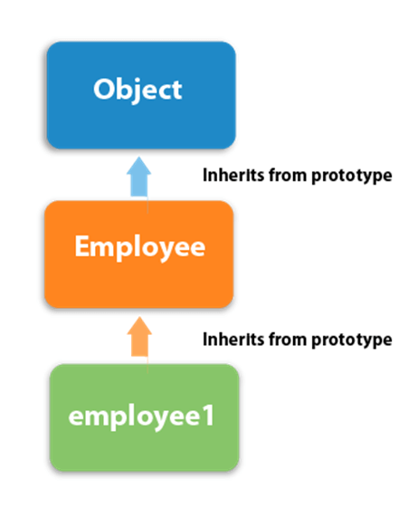

JavaScript Prototype Object Example 1
Let's see an example to add a new method to the constructor function.
- <script>
- function Employee(firstName,lastName)
- {
- this.firstName=firstName;
- this.lastName=lastName;
- }

- Employee.prototype.fullName=function()
- {
- return this.firstName+" "+this.lastName;
- }

- var employee1=new Employee("Martin","Roy");
- var employee2=new Employee("Duke", "William");
- document.writeln(employee1.fullName()+"<br>");
- document.writeln(employee2.fullName());
- </script>

JavaScript Constructor Method
A JavaScript constructor method is a special type of method which is used to initialize and create an object. It is called when memory is allocated for an object.

Points to remember
- The constructor keyword is used to declare a constructor method.
- The class can contain one constructor method only.
- JavaScript allows us to use parent class constructor through super keyword.

Constructor Method Example
Let's see a simple example of a constructor method.
<script>
class Employee {
constructor() {
this.id=101;
this.name = "Martin Roy";
}
}
var emp = new Employee();
document.writeln(emp.id+" "+emp.name);
</script>

Output:
101 Martin Roy

Constructor Method Example: super keyword
The super keyword is used to call the parent class constructor. Let's see an example.
- <script>
- class CompanyName
- {
- constructor()
- {
- this.company="Java";
- }
- }
- class Employee extends CompanyName {
- constructor(id,name) {
- super();
- this.id=id;
- this.name=name;
- }
- }
- var emp = new Employee(1,"John");
- document.writeln(emp.id+" "+emp.name+" "+emp.company);
- </script>

JavaScript static Method
The JavaScript provides static methods that belong to the class instead of an instance of that class. So, an instance is not required to call the static method. These methods are called directly on the class itself.

Points to remember
- The static keyword is used to declare a static method.
- The static method can be of any name.
- A class can contain more than one static method.
- If we declare more than one static method with a similar name, the JavaScript always invokes the last one.
- The static method can be used to create utility functions.
- We can use this keyword to call a static method within another static method.
- We cannot use this keyword directly to call a static method within the non-static method. In such case, we can call the static method either using the class name or as the property of the constructor.

JavaScript static Method Example 1
Let's see a simple example of a static method.
- <script>
- class Test
- {
- static display()
- {
- return "static method is invoked"
- }
- }
- document.writeln(Test.display());
- </script>

JavaScript Encapsulation
The JavaScript Encapsulation is a process of binding the data (i.e. variables) with the functions acting on that data. It allows us to control the data and validate it. To achieve an encapsulation in JavaScript: -
- Use var keyword to make data members private.
- Use setter methods to set the data and getter methods to get that data.
The encapsulation allows us to handle an object using the following properties:
Read/Write - Here, we use setter methods to write the data and getter methods read that data.
Read Only - In this case, we use getter methods only.
Write Only - In this case, we use setter methods only.

JavaScript Encapsulation Example
Let's see a simple example of encapsulation that contains two data members with its setter and getter methods.
- <script>
- class Student
- {
- constructor()
- {
- var name;
- var marks;
- }
- getName()
- {
- return this.name;
- }
- setName(name)
- {
- this.name=name;
- }

- getMarks()
- {
- return this.marks;
- }
- setMarks(marks)
- {
- this.marks=marks;
- }

- }
- var stud=new Student();
- stud.setName("John");
- stud.setMarks(80);
- document.writeln(stud.getName()+" "+stud.getMarks());
- </script>

JavaScript Inheritance
The JavaScript inheritance is a mechanism that allows us to create new classes on the basis of already existing classes. It provides flexibility to the child class to reuse the methods and variables of a parent class.
The JavaScript extends keyword is used to create a child class on the basis of a parent class. It facilitates child class to acquire all the properties and behavior of its parent class.

Points to remember
- It maintains an IS-A relationship.
- The extends keyword is used in class expressions or class declarations.
- Using extends keyword, we can acquire all the properties and behavior of the inbuilt object as well as custom classes.
- We can also use a prototype-based approach to achieve inheritance.

JavaScript extends Example: inbuilt object
In this example, we extends Date object to display today's date.
- <script>
- class Moment extends Date {
- constructor() {
- super();
- }}
- var m=new Moment();
- document.writeln("Current date:")
- document.writeln(m.getDate()+"-"+(m.getMonth()+1)+"-"+m.getFullYear());
- </script>

Output:
41.3M
937
OOPs Concepts in Java
Current date: 31-8-2018
Let's see one more example to display the year value from the given date.
- <script>
- class Moment extends Date {
- constructor(year) {
- super(year);
- }}
- var m=new Moment("August 15, 1947 20:22:10");
- document.writeln("Year value:")
- document.writeln(m.getFullYear());
- </script>

Output:
Year value: 1947

JavaScript extends Example: Custom class
In this example, we declare sub-class that extends the properties of its parent class.
- <script>
- class Bike
- {
- constructor()
- {
- this.company="Honda";
- }
- }
- class Vehicle extends Bike {
- constructor(name,price) {
- super();
- this.name=name;
- this.price=price;
- }
- }
- var v = new Vehicle("Shine","70000");
- document.writeln(v.company+" "+v.name+" "+v.price);
- </script>

JavaScript Abstraction
An abstraction is a way of hiding the implementation details and showing only the functionality to the users. In other words, it ignores the irrelevant details and shows only the required one.

Points to remember
- We cannot create an instance of Abstract Class.
- It reduces the duplication of code.

JavaScript Abstraction Example

Example 1
Let's check whether we can create an instance of Abstract class or not.
- <script>
- //Creating a constructor function
- function Vehicle()
- {
- this.vehicleName= vehicleName;
- throw new Error("You cannot create an instance of Abstract class");

- }
- Vehicle.prototype.display=function()
- {
- return this.vehicleName;
- }
- var vehicle=new Vehicle();
- </script>
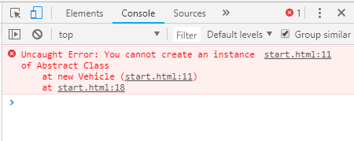

Example 2
Let's see an example to achieve abstraction.
- <script>
- //Creating a constructor function
- function Vehicle()
- {
- this.vehicleName="vehicleName";
- throw new Error("You cannot create an instance of Abstract Class");
- }
- Vehicle.prototype.display=function()
- {
- return "Vehicle is: "+this.vehicleName;
- }
- //Creating a constructor function
- function Bike(vehicleName)
- {
- this.vehicleName=vehicleName;
- }
- //Creating object without using the function constructor
- Bike.prototype=Object.create(Vehicle.prototype);
- var bike=new Bike("Honda");
- document.writeln(bike.display());

- </script>

JavaScript Events
The change in the state of an object is known as an Event. In html, there are various events which represents that some activity is performed by the user or by the browser. When javascript code is included in HTML, js react over these events and allow the execution. This process of reacting over the events is called Event Handling. Thus, js handles the HTML events via Event Handlers.
For example, when a user clicks over the browser, add js code, which will execute the task to be performed on the event.
Some of the HTML events and their event handlers are:

Mouse events:
Event Performed | Event Handler | Description
Click | onclick | When mouse click on an element
Mouseover | onmouseover | When the cursor of the mouse comes over the element
Mouseout | onmouseout | When the cursor of the mouse leaves an element
Mousedown | onmousedown | When the mouse button is pressed over the element
Mouseup | onmouseup | When the mouse button is released over the element
Mousemove | onmousemove | When the mouse movement takes place.

Keyboard events:
Event Performed | Event Handler | Description
Keydown & Keyup | onkeydown & onkeyup | When the user press and then release the key

Form events:
Event Performed | Event Handler | Description
Focus | Onfocus | When the user focuses on an element
Submit | Onsubmit | When the user submits the form
Blur | Onblur | When the focus is away from a form element
Change | Onchange | When the user modifies or changes the value of a form element

Window/Document events
Event Performed | Event Handler | Description
Load | Onload | When the browser finishes the loading of the page
Unload | Onunload | When the visitor leaves the current webpage, the browser unloads it
Resize | Onresize | When the visitor resizes the window of the browser
Let's discuss some examples over events and their handlers.

Click Event
- <html>
- <head> Javascript Events </head>
- <body>
- <script language="Javascript" type="text/Javascript">

- function clickevent()
- {
- document.write("This is Java");
- }

- </script>
- <form>
- <input type="button" onclick="clickevent()" value="Who's this?"/>
- </form>
- </body>
- </html>

MouseOver Event
- <html>
- <head>
- <h1> Javascript Events </h1>
- </head>
- <body>
- <script language="Javascript" type="text/Javascript">
- <!--
- function mouseoverevent()
- {
- alert("This is Java");
- }
- //-->
- </script>
- <p onmouseover="mouseoverevent()"> Keep cursor over me</p>
- </body>
- </html>

Focus Event
- <html>
- <head> Javascript Events</head>
- <body>
- <h2> Enter something here</h2>
- <input type="text" id="input1" onfocus="focusevent()"/>
- <script>
- <!--
- function focusevent()
- {
- document.getElementById("input1").style.background=" aqua";
- }
- //-->
- </script>
- </body>
- </html>

Keydown Event
- <html>
- <head> Javascript Events</head>
- <body>
- <h2> Enter something here</h2>
- <input type="text" id="input1" onkeydown="keydownevent()"/>
- <script>
- <!--
- function keydownevent()
- {
- document.getElementById("input1");
- alert("Pressed a key");
- }
- //-->
- </script>
- </body>
- </html>

Load event
- <html>
- <head>Javascript Events</head>
- </br>
- <body onload="window.alert('Page successfully loaded');">
- <script>
- <!--
- document.write("The page is loaded successfully");
- //-->
- </script>
- </body>
- </html>

JavaScript addEventListener()
The addEventListener() method is used to attach an event handler to a particular element. It does not override the existing event handlers. Events are said to be an essential part of the JavaScript. A web page responds according to the event that occurred. Events can be user-generated or generated by API's. An event listener is a JavaScript's procedure that waits for the occurrence of an event.
The addEventListener() method is an inbuilt function of JavaScript. We can add multiple event handlers to a particular element without overwriting the existing event handlers.

Syntax
- element.addEventListener(event, function, useCapture);
Although it has three parameters, the parameters event and function are widely used. The third parameter is optional to define. The values of this function are defined as follows.

Parameter Values
event: It is a required parameter. It can be defined as a string that specifies the event's name.
44.2M
716
Hello Java Program for Beginners

Note: Do not use any prefix such as "on" with the parameter value. For example, Use "click" instead of using "onclick".
function: It is also a required parameter. It is a JavaScript function which responds to the event occur.
useCapture: It is an optional parameter. It is a Boolean type value that specifies whether the event is executed in the bubbling or capturing phase. Its possible values are true and false. When it is set to true, the event handler executes in the capturing phase. When it is set to false, the handler executes in the bubbling phase. Its default value is false.
Let's see some of the illustrations of using the addEventListener() method.

Example
It is a simple example of using the addEventListener() method. We have to click the given HTML button to see the effect.
- <!DOCTYPE html>
- <html>
- <body>
- <p> Example of the addEventListener() method. </p>
- <p> Click the following button to see the effect. </p>
- <button id = "btn"> Click me </button>
- <p id = "para"></p>
- <script>
- document.getElementById("btn").addEventListener("click", fun);
- function fun() {
- document.getElementById("para").innerHTML = "Hello World" + "<br>" + "Welcome to the java.com";
- }
- </script>
- </body>
- </html>

Output
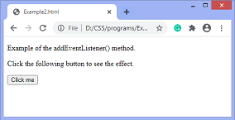
After clicking the given HTML button, the output will be -
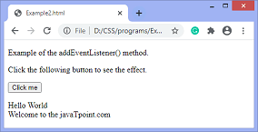
Now, in the next example we will see how to add many events to the same element without overwriting the existing events.

Example
In this example, we are adding multiple events to the same element.
- <!DOCTYPE html>
- <html>
- <body>
- <p> This is an example of adding multiple events to the same element. </p>
- <p> Click the following button to see the effect. </p>
- <button id = "btn"> Click me </button>
- <p id = "para"></p>
- <p id = "para1"></p>
- <script>
- function fun() {
- alert("Welcome to the java.com");
- }

- function fun1() {
- document.getElementById("para").innerHTML = "This is second function";

- }
- function fun2() {
- document.getElementById("para1").innerHTML = "This is third function";
- }
- var mybtn = document.getElementById("btn");
- mybtn.addEventListener("click", fun);
- mybtn.addEventListener("click", fun1);
- mybtn.addEventListener("click", fun2);
- </script>
- </body>
- </html>

Output
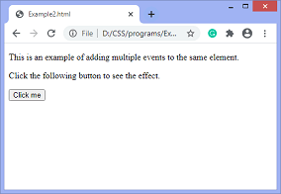
Now, when we click the button, an alert will be displayed. After clicking the given HTML button, the output will be -
When we exit the alert, the output is -
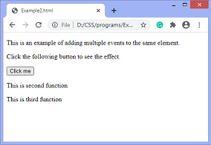

Example
In this example, we are adding multiple events of a different type to the same element.
- <!DOCTYPE html>
- <html>
- <body>
- <p> This is an example of adding multiple events of different type to the same element. </p>
- <p> Click the following button to see the effect. </p>
- <button id = "btn"> Click me </button>
- <p id = "para"></p>
- <script>
- function fun() {
- btn.style.width = "50px";
- btn.style.height = "50px";
- btn.style.background = "yellow";
- btn.style.color = "blue";
- }

- function fun1() {
- document.getElementById("para").innerHTML = "This is second function";

- }
- function fun2() {
- btn.style.width = "";
- btn.style.height = "";
- btn.style.background = "";
- btn.style.color = "";
- }
- var mybtn = document.getElementById("btn");
- mybtn.addEventListener("mouseover", fun);
- mybtn.addEventListener("click", fun1);
- mybtn.addEventListener("mouseout", fun2);
- </script>
- </body>
- </html>

Output
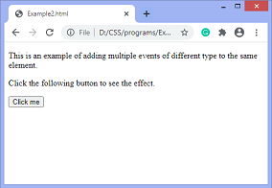
When we move the cursor over the button, the output will be -
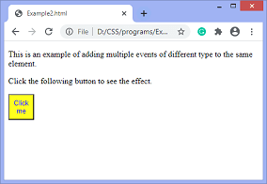
After clicking the button and leave the cursor, the output will be -
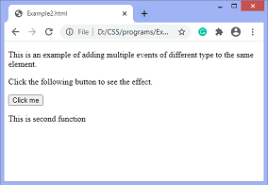

Event Bubbling or Event Capturing
Now, we understand the use of the third parameter of JavaScript's addEventListener(), i.e., useCapture.
In HTML DOM, Bubbling and Capturing are the two ways of event propagation. We can understand these ways by taking an example.
Suppose we have a div element and a paragraph element inside it, and we are applying the "click" event to both of them using the addEventListener() method. Now the question is on clicking the paragraph element, which element's click event is handled first.
So, in Bubbling, the event of paragraph element is handled first, and then the div element's event is handled. It means that in bubbling, the inner element's event is handled first, and then the outermost element's event will be handled.
In Capturing the event of div element is handled first, and then the paragraph element's event is handled. It means that in capturing the outer element's event is handled first, and then the innermost element's event will be handled.
- addEventListener(event, function, useCapture);
We can specify the propagation using the useCapture parameter. When it is set to false (which is its default value), then the event uses bubbling propagation, and when it is set to true, there is the capturing propagation.
We can understand the bubbling and capturing using an illustration.

Example
In this example, there are two div elements. We can see the bubbling effect on the first div element and the capturing effect on the second div element.
When we double click the span element of the first div element, then the span element's event is handled first than the div element. It is called bubbling.
But when we double click the span element of the second div element, then the div element's event is handled first than the span element. It is called capturing.
- <!DOCTYPE html>
- <html>
- <head>
- <style>
- div{
- background-color: lightblue;
- border: 2px solid red;
- font-size: 25px;
- text-align: center;
- }
- span{
- border: 2px solid blue;
- }
- </style>
- </head>
- <body>
- <h1> Bubbling </h1>
- <div id = "d1">
- This is a div element.
- <br><br>
- <span id = "s1"> This is a span element. </span>
- </div>
- <h1> Capturing </h1>
- <div id = "d2"> This is a div element.
- <br><br>
- <span id = "s2"> This is a span element. </span>
- </div>

- <script>
- document.getElementById("d1").addEventListener("dblclick", function() {alert('You have double clicked on div element')}, false);
- document.getElementById("s1").addEventListener("dblclick", function() {alert('You have double clicked on span element')}, false);
- document.getElementById("d2").addEventListener("dblclick", function() {alert('You have double clicked on div element')}, true);
- document.getElementById("s2").addEventListener("dblclick", function() {alert('You have double clicked on span element')}, true);
- </script>
- </body>
- </html>

Output
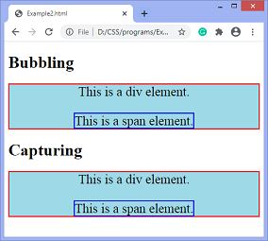

JavaScript onclick event
The onclick event generally occurs when the user clicks on an element. It allows the programmer to execute a JavaScript's function when an element gets clicked. This event can be used for validating a form, warning messages and many more.
Using JavaScript, this event can be dynamically added to any element. It supports all HTML elements except <html>, <head>, <title>, <style>, <script>, <base>, <iframe>, <bdo>, <br>, <Meta>, and <param>. It means we cannot apply the onclick event on the given tags.
In HTML, we can use the onclick attribute and assign a JavaScript function to it. We can also use the JavaScript's addEventListener() method and pass a click event to it for greater flexibility.

Syntax
Now, we see the syntax of using the onclick event in HTML and in javascript (without addEventListener() method or by using the addEventListener() method).
00:00/02:28

In HTML
- <element onclick = "fun()">

In JavaScript
- object.onclick = function() { myScript };

In JavaScript by using the addEventListener() method
- object.addEventListener("click", myScript);
Let's see how to use onclick event by using some illustrations. Now, we will see the examples of using the onclick event in HTML, and in JavaScript.

Example1 - Using onclick attribute in HTML
In this example, we are using the HTML onclick attribute and assigning a JavaScript's function to it. When the user clicks the given button, the corresponding function will get executed, and an alert dialog box will be displayed on the screen.
- <!DOCTYPE html>
<html>
<head>
<script>
function fun() {
alert("Welcome to the java.com");
}
</script>
</head>
<body>
<h3> This is an example of using onclick attribute in HTML. </h3>
<p> Click the following button to see the effect. </p>
<button onclick = "fun()">Click me</button>
</body>
</html>

Output
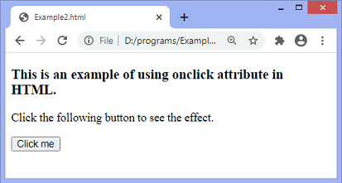
After clicking the given button, the output will be -

Example2 - Using JavaScript
In this example, we are using JavaScript's onclick event. Here we are using the onclick event with the paragraph element.
When the user clicks on the paragraph element, the corresponding function will get executed, and the text of the paragraph gets changed. On clicking the <p> element, the background color, size, border, and color of the text will also get change.
- <!DOCTYPE html>
<html>
<head>
<title> onclick event </title>
</head>
<body>
<h3> This is an example of using onclick event. </h3>
<p> Click the following text to see the effect. </p>
<p id = "para">Click me</p>
<script>
document.getElementById("para").onclick = function() {
fun()
};
function fun() {
document.getElementById("para").innerHTML = "Welcome to the java.com";
document.getElementById("para").style.color = "blue";
document.getElementById("para").style.backgroundColor = "yellow";
document.getElementById("para").style.fontSize = "25px";
document.getElementById("para").style.border = "4px solid red";
}
</script>

</body>
</html>

Output
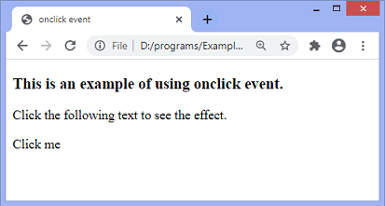
After clicking the text Click me, the output will be -

Example3 - Using addEventListener() method
In this example, we are using JavaScript's addEventListener() method to attach a click event to the paragraph element. When the user clicks the paragraph element, the text of the paragraph gets changed.
On clicking the paragraph, the background color and font-size of elements will also change.
- <!DOCTYPE html>
- <html>
- <head>
- </head>
- <body>
- <h3> This is an example of using click event. </h3>
- <p> Click the following text to see the effect. </p>
- <p id = "para">Click me</p>
- <script>
- document.getElementById("para").onclick = function() {
- fun()
- };
- function fun() {
- document.getElementById("para").innerHTML = "Welcome to the java.com";
- document.getElementsByTagName("body")[0].style.color = "blue";
- document.getElementsByTagName("body")[0].style.backgroundColor = "lightgreen";
- document.getElementsByTagName("body")[0].style.fontSize = "25px";
- document.getElementById("para").style.border = "4px solid red";
- }
- </script>

- </body>
- </html>

Output
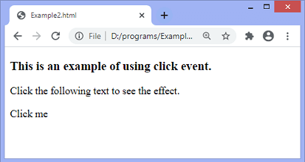
On clicking the text Click me, the output will be -

JavaScript dblclick event
The dblclick event generates an event on double click the element. The event fires when an element is clicked twice in a very short span of time. We can also use the JavaScript's addEventListener() method to fire the double click event.
In HTML, we can use the ondblclick attribute to create a double click event.

Syntax
Now, we see the syntax of creating double click event in HTML and in javascript (without using addEventListener() method or by using the addEventListener() method).

In HTML
- <element ondblclick = "fun()">

In JavaScript
- object.ondblclick = function() { myScript };

In JavaScript by using the addEventListener() method
- object.addEventListener("dblclick", myScript);
Let's see some of the illustrations to understand the double click event.

Example - Using ondblclick attribute in HTML
In this example, we are creating the double click event using the HTML ondblclick attribute.
- <!DOCTYPE html>
- <html>
- <head>
- </head>

- <body>
- <h1 id = "heading" ondblclick = "fun()"> Hello world :):) </h1>
- <h2> Double Click the text "Hello world" to see the effect. </h2>
- <p> This is an example of using the <b> ondblclick </b> attribute. </p>
- <script>
- function fun() {
- document.getElementById("heading").innerHTML = " Welcome to the java.com ";
- }
- </script>
- </body>
- </html>

Output
After the execution of the above code, the output will be -
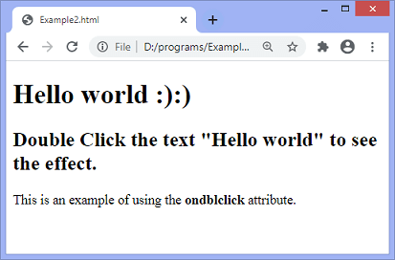
After double-clicking the text "Hello world", the output will be -
Now, we will see how to create double click event using JavaScript.

Example - Using JavaScript
- <!DOCTYPE html>
- <html>
- <head>
- </head>

- <body>
- <h1 id = "heading"> Hello world :):) </h1>
- <h2> Double Click the text "Hello world" to see the effect. </h2>
- <p> This is an example of creating the double click event using JavaScript. </p>
- <script>
- document.getElementById("heading").ondblclick = function() { fun() };
- function fun() {
- document.getElementById("heading").innerHTML = " Welcome to the java.com ";
- }
- </script>
- </body>

- </html>

Output
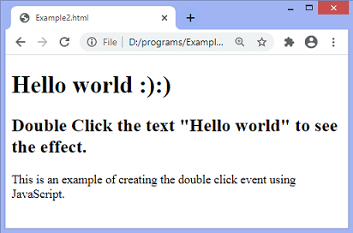
After double-clicking the text "Hello world", the output will be -

Example - Using JavaScript's addEventListener() method
- <!DOCTYPE html>
<html>
<head>
</head>

<body>
<h1 id = "heading"> Hello world :):) </h1>
<h2> Double Click the text "Hello world" to see the effect. </h2>
<p> This is an example of creating the double click event using the <b> addEventListener() method </b>. </p>
<script>
document.getElementById("heading").addEventListener("dblclick", fun);
function fun() {
document.getElementById("heading").innerHTML = " Welcome to the java.com ";
}
</script>
</body>

</html>

Output
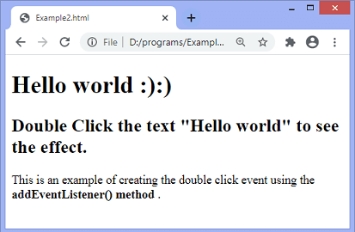
After double-clicking the text "Hello world", the output will be -
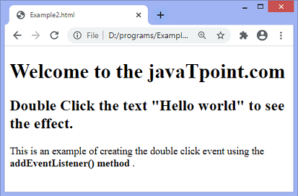

JavaScript onload
In JavaScript, this event can apply to launch a particular function when the page is fully displayed. It can also be used to verify the type and version of the visitor's browser. We can check what cookies a page uses by using the onload attribute.
In HTML, the onload attribute fires when an object has been loaded. The purpose of this attribute is to execute a script when the associated element loads.
In HTML, the onload attribute is generally used with the <body> element to execute a script once the content (including CSS files, images, scripts, etc.) of the webpage is completely loaded. It is not necessary to use it only with <body> tag, as it can be used with other HTML elements.
The difference between the document.onload and window.onload is: document.onload triggers before the loading of images and other external content. It is fired before the window.onload. While the window.onload triggers when the entire page loads, including CSS files, script files, images, etc.
5

Syntax
- window.onload = fun()
Let's understand this event by using some examples.

Example1
In this example, there is a div element with a height of 200px and a width of 200px. Here, we are using the window.onload() to change the background color, width, and height of the div element after loading the web page.
The background color is set to 'red', and width and height are set to 300px each.
- <!DOCTYPE html>
<html>
<head>
<meta charset = " utf-8">
<title> window.onload() </title>
<style type = "text/css">
#bg{
width: 200px;
height: 200px;
border: 4px solid blue;
}
</style>
<script type = "text/javascript">
window.onload = function(){
document.getElementById("bg").style.backgroundColor = "red";
document.getElementById("bg").style.width = "300px";
document.getElementById("bg").style.height = "300px";
}
</script>
</head>
<body>
<h2> This is an example of window.onload() </h2>
<div id = "bg"></div>
</body>
</html>

Output
After the execution of the code and loading of the page, the output will be -
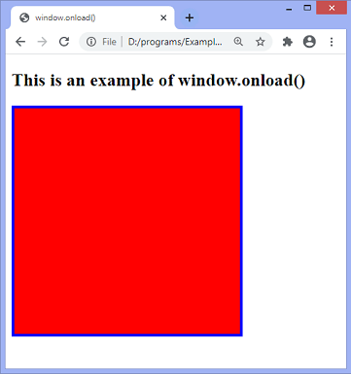

Example2
In this example, we are implementing a simple animation by using the properties of the DOM object and functions of javascript. We use the JavaScript function getElementById() for getting the DOM object and then assign that object into a global variable.
<html>
<head>
<script type = "text/javascript">

var img = null;
function init(){
img = document.getElementById('myimg');
img.style.position = 'relative';
img.style.left = '50px';
}
function moveRight(){
img.style.left = parseInt(
img.style.left) + 100 + 'px';
}
window.onload = init;

</script>
</head>

<body>
<form>
<img id = "myimg" src = "train1.png" />
<center>
<p>Click the below button to move the image right</p>
<input type = "button" value = "Click Me" onclick = "moveRight();" />
</center>
</form>
</body>

</html>

Output
After the successful execution of the above code, the output will be -
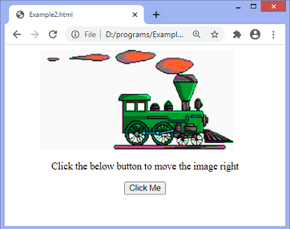
Now, there is an example in which we will use the HTML onload attribute and the JavaScript functions.

Example3
It is a simple example of using the HTML onload attribute with the function defined in JavaScript. In this example, the alert() function gets called whenever the document refresh.
- <!DOCTYPE html>
- <html>
- <head>
- <style>
- </style>
- <script>
- function fun() {
- alert("Hello World!!, Welcome to the java.com");
- }
- </script>
- </head>
- <body onload = "fun()">
- <h1> Example of the HTML onload attribute </h1>
- <p> Try to refresh the document to see the effect. </p>
- </body>
- </html>

Output
After the execution of the above code, the output will be -
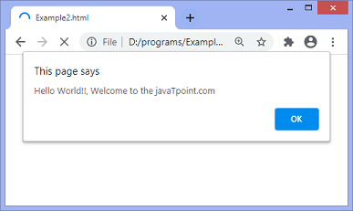

JavaScript onresize event
The onresize event in JavaScript generally occurs when the window has been resized. To get the size of the window, we can use the JavaScript's window.outerWidth and window.outerHeight events. We can also use the JavaScript's properties such as innerWidth, innerHeight, clientWidth, ClientHeight, offsetWidth, offsetHeight to get the size of an element.
In HTML, we can use the onresize attribute and assign a JavaScript function to it. We can also use the JavaScript's addEventListener() method and pass a resize event to it for greater flexibility.

Syntax
Now, we see the syntax of using the onresize event in HTML and in javascript (without addEventListener() method or by using the addEventListener() method).

In HTML
- <element onresize = "fun()">

In JavaScript
- object.onresize = function() { myScript };

In JavaScript by using the addEventListener() method
- object.addEventListener("resize", myScript);
Let's see some of the illustrations to understand the onresize event.
00:00/07:31

Example
In this example, we are using the HTML onresize attribute. Here, we are using the window.outerWidth and window.outerHeight events of JavaScript to get the height and width of the window.
When the user resizes the window, the updated width and height of the window will be displayed on the screen. It will also display how many times the user tried to resize the window. When we change the height of the window, the updated height will change accordingly. Similarly, when we change the width of the window, the updated width will change accordingly.
- <!DOCTYPE html>
<html>
<head>
<script>
var i = 0;

function fun() {
var res = "Width = " + window.outerWidth + "<br>" + "Height = " + window.outerHeight;
document.getElementById("para").innerHTML = res;

var res1 = i += 1;
document.getElementById("s1").innerHTML = res1;
}
</script>
</head>
<body onresize = "fun()">
<h3> This is an example of using onresize attribute. </h3>
<p> Try to resize the browser's window to see the effect. </p>

<p id = "para"> </p>
<p> You have resized the window <span id = "s1"> 0 </span> times.</p>
</body>
</html>

Output
After the execution of the above code, the output will be -
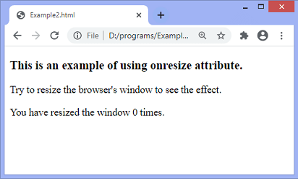
When we try to resize the window, the output will be -
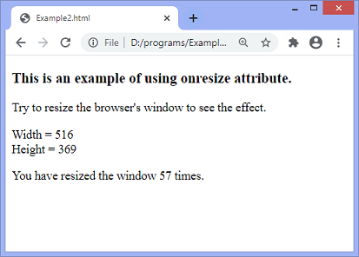

Example - Using JavaScript
In this example, we are using JavaScript's onresize event.
- <!DOCTYPE html>
<html>
<head>
</head>
<body>
<h3> This is an example of using JavaScript's onresize event. </h3>
<p> Try to resize the browser's window to see the effect. </p>

<p id = "para"> </p>
<p> You have resized the window <span id = "s1"> 0 </span> times.</p>
<script>
document.getElementsByTagName("BODY")[0].onresize = function() {fun()};
var i = 0;

function fun() {
var res = "Width = " + window.outerWidth + "<br>" + "Height = " + window.outerHeight;
document.getElementById("para").innerHTML = res;

var res1 = i += 1;
document.getElementById("s1").innerHTML = res1;
}
</script>
</body>
</html>
Output
After the execution of the above code, the output will be -
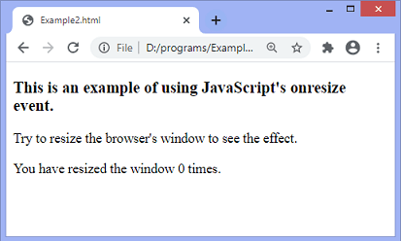
When we try to resize the window, the output will be -
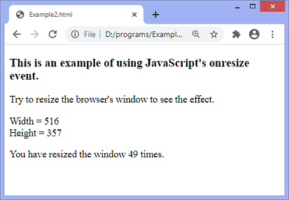

Example - Using addEventListener() method
In this example, we are using JavaScript's addEventListener() method.
- <!DOCTYPE html>
- <html>
- <head>
- </head>
- <body>
- <h3> This is an example of using JavaScript's addEventListener() method. </h3>
- <p> Try to resize the browser's window to see the effect. </p>

- <p id = "para"> </p>
- <p> You have resized the window <span id = "s1"> 0 </span> times.</p>
- <script>
- window.addEventListener("resize", fun);
- var i = 0;

- function fun() {
- var res = "Width = " + window.outerWidth + "<br>" + "Height = " + window.outerHeight;
- document.getElementById("para").innerHTML = res;

- var res1 = i += 1;
- document.getElementById("s1").innerHTML = res1;
- }
- </script>
- </body>
- </html>

Output
After the execution of the above code, the output will be -
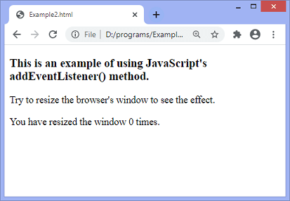
When we try to resize the window, the output will be -
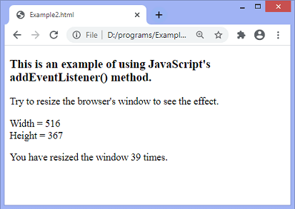

JavaScript Cookies
A cookie is an amount of information that persists between a server-side and a client-side. A web browser stores this information at the time of browsing.
A cookie contains the information as a string generally in the form of a name-value pair separated by semi-colons. It maintains the state of a user and remembers the user's information among all the web pages.

How Cookies Works?
- When a user sends a request to the server, then each of that request is treated as a new request sent by the different user.
- So, to recognize the old user, we need to add the cookie with the response from the server.
- browser at the client-side.
- Now, whenever a user sends a request to the server, the cookie is added with that request automatically. Due to the cookie, the server recognizes the users.
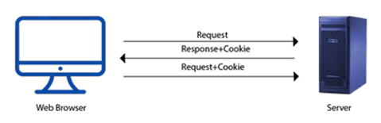

How to create a Cookie in JavaScript?
In JavaScript, we can create, read, update and delete a cookie by using document.cookie property.
The following syntax is used to create a cookie:
- document.cookie="name=value";

JavaScript Cookie Example

Example 1
Let's see an example to set and get a cookie.
- <!DOCTYPE html>
- <html>
- <head>
- </head>
- <body>
- <input type="button" value="setCookie" onclick="setCookie()">
- <input type="button" value="getCookie" onclick="getCookie()">
- <script>
- function setCookie()
- {
- document.cookie="username=Duke Martin";
- }
- function getCookie()
- {
- if(document.cookie.length!=0)
- {
- alert(document.cookie);
- }
- else
- {
- alert("Cookie not available");
- }
- }
- </script>

- </body>
- </html>

Example 2
Here, we display the cookie's name-value pair separately.
<!DOCTYPE html>
<html>
<head>
</head>
<body>
<input type="button" value="setCookie" onclick="setCookie()">
<input type="button" value="getCookie" onclick="getCookie()">
<script>
function setCookie()
{
document.cookie="username=Duke Martin";
}
function getCookie()
{
if(document.cookie.length!=0)
{
var array=document.cookie.split("=");
alert("Name="+array[0]+" "+"Value="+array[1]);
}
else
{
alert("Cookie not available");
}
}
</script>

</body>
</html>

Example 3
In this example, we provide choices of color and pass the selected color value to the cookie. Now, cookie stores the last choice of a user in a browser. So, on reloading the web page, the user's last choice will be shown on the screen.
- <!DOCTYPE html>
- <html>
- <head>
- </head>
- <body>
- <select id="color" onchange="display()">
- <option value="Select Color">Select Color</option>
- <option value="yellow">Yellow</option>
- <option value="green">Green</option>
- <option value="red">Red</option>
- </select>
- <script type="text/javascript">
- function display()
- {
  - var value = document.getElementById("color").value;
  - if (value != "Select Color")
  - {
  - document.bgColor = value;
  - document.cookie = "color=" + value;
  - }
- }
- window.onload = function ()
- {
  - if (document.cookie.length != 0)
  - {
  - var array = document.cookie.split("=");
  - document.getElementById("color").value = array[1];
  - document.bgColor = array[1];
  - }
- }

- </script>
- </body>
- </html>

Cookie Attributes
JavaScript provides some optional attributes that enhance the functionality of cookies. Here, is the list of some attributes with their description.
Attributes | Description
Expires | It maintains the state of a cookie up to the specified date and time.
max-age | It maintains the state of a cookie up to the specified time. Here, time is given in seconds.
Path | It expands the scope of the cookie to all the pages of a website.
Domain | It is used to specify the domain for which the cookie is valid.

Cookie expires attribute
The cookie expires attribute provides one of the ways to create a persistent cookie. Here, a date and time are declared that represents the active period of a cookie. Once the declared time is passed, a cookie is deleted automatically.
Let's see an example of cookie expires attribute.
- <!DOCTYPE html>
<html>
<head>
</head>
<body>
<input type="button" value="setCookie" onclick="setCookie()">
<input type="button" value="getCookie" onclick="getCookie()">
<script>
function setCookie()
{
document.cookie="username=Duke Martin;expires=Sun, 20 Aug 2030 12:00:00 UTC";
}
function getCookie()
{
if(document.cookie.length!=0)
{
var array=document.cookie.split("=");
alert("Name="+array[0]+" "+"Value="+array[1]);
}
else
{
alert("Cookie not available");
}
}
</script>
</body>
</html>

Cookie max-age attribute
The cookie max-age attribute provides another way to create a persistent cookie. Here, time is declared in seconds. A cookie is valid up to the declared time only.
Let's see an example of cookie max-age attribute.
<!DOCTYPE html>
<html>
<head>
</head>
<body>
<input type="button" value="setCookie" onclick="setCookie()">
<input type="button" value="getCookie" onclick="getCookie()">
<script>
function setCookie()
{
document.cookie="username=Duke Martin;max-age=" + (60 * 60 * 24 * 365) + ";"
}
function getCookie()
{
if(document.cookie.length!=0)
{
var array=document.cookie.split("=");
alert("Name="+array[0]+" "+"Value="+array[1]);
}
else
{
alert("Cookie not available");
}
}
</script>
</body>
</html>
In this example, we use path attribute to enhance the visibility of cookies up to all the pages. Here, you all just need to do is to maintain the above directory structure and put the below program in all three web pages. Now, the cookie is valid for each web page.
- <!DOCTYPE html>
<html>
<head>
</head>
<body>
<input type="button" value="setCookie" onclick="setCookie()">
<input type="button" value="getCookie" onclick="getCookie()">
<script>
function setCookie()
{
document.cookie="username=Duke Martin;max-age=" + (60 * 60 * 24 * 365) + ";path=/;"
}
function getCookie()
{
if(document.cookie.length!=0)
{
var array=document.cookie.split("=");
alert("Name="+array[0]+" "+"Value="+array[1]);
}
else
{
alert("Cookie not available");
}
}
</script>
</body>
</html>

Cookie domain attribute
A JavaScript domain attribute specifies the domain for which the cookie is valid. Let's suppose if we provide any domain name to the attribute such like:
- domain=java.com
Here, the cookie is valid for the given domain and all its sub-domains.
However, if we provide any sub-domain to the attribute such like:
- omain=training.java.com
Here, the cookie is valid only for the given sub-domain. So, it's a better approach to provide domain name instead of sub-domain.

Cookie with multiple Name-Value pairs
In JavaScript, a cookie can contain only a single name-value pair. However, to store more than one name-value pair, we can use the following approach: -
- Serialize the custom object in a JSON string, parse it and then store in a cookie.
- For each name-value pair, use a separate cookie.

Examples to Store Name-Value pair in a Cookie

Example 1
Let's see an example to check whether a cookie contains more than one name-value pair.
- <!DOCTYPE html>
<html>
<head>
</head>
<body>
Name: <input type="text" id="name"><br>
Email: <input type="email" id="email"><br>
Course: <input type="text" id="course"><br>
<input type="button" value="Set Cookie" onclick="setCookie()">
<input type="button" value="Get Cookie" onclick="getCookie()">
<script>
function setCookie()
{
//Declaring 3 key-value pairs
var info="Name="+ document.getElementById("name").value+";Email="+document.getElementById("email").value+";Course="+document.getElementById("course").value;
//Providing all 3 key-value pairs to a single cookie
document.cookie=info;
}

function getCookie()
{
if(document.cookie.length!=0)
{
//Invoking key-value pair stored in a cookie
alert(document.cookie);
}
else
{
alert("Cookie not available")
}
}
</script>
</body>
</html>

Deleting a Cookie in JavaScript
In the previous section, we learned the different ways to set and update a cookie in JavaScript. Apart from that, JavaScript also allows us to delete a cookie. Here, we see all the possible ways to delete a cookie.

Different ways to delete a Cookie
These are the following ways to delete a cookie:
- A cookie can be deleted by using expire attribute.
- A cookie can also be deleted by using max-age attribute.
- We can delete a cookie explicitly, by using a web browser.

Examples to delete a Cookie

Example 1
In this example, we use expire attribute to delete a cookie by providing expiry date (i.e. any past date) to it.
- <!DOCTYPE html>
<html>
<head>
</head>
<body>

<input type="button" value="Set Cookie" onclick="setCookie()">
<input type="button" value="Get Cookie" onclick="getCookie()">
<script>
function setCookie()
{
document.cookie="name=Martin Roy; expires=Sun, 20 Aug 2000 12:00:00 UTC";

}
function getCookie()
{
if(document.cookie.length!=0)
{
alert(document.cookie);
}
else
{
alert("Cookie not avaliable");
}
}
</script>
</body>
</html>

JavaScript For In Loop

The JavaScript for...in loop iterates over the properties of an object. It allows you to access each key or property name of an object.

const car = {
make: "Toyota",
model: "Corolla",
year: 2020
};
​
for (let key in car) {
console.log(`${key}: ${car[key]}`);
}
Output
make: Toyota
model: Corolla
year: 2020
Syntax
for (key in object) { // Code}

The for...in loop can also works to iterate over the properties of an array, but it is not recommended. for..in is mainly suitable for objects.
For arrays, we should use below loops.
- For of Loop if we need to put continue or break in the loop
- forEach() if we need execute something for all elements without any condition
// Example of for in for arrays
// Not a recommended way to traverse
// an array
const a = [1, 2, 3, 4, 5];
​
for (const i in a) {
console.log(a[i]);
}
Output
1
2
3
4
5

Important Facts About for in Loop
- The for...in loop is not recommended for use with arrays if maintaining index order is important.
- The order of iteration in for...in loop is implementation-dependent, means the array elements may not be accessed in the expected sequence.
- The order in which properties are iterated may not match the properties that are defined in the object.

Associative Arrays in JavaScript

Associative arrays in JavaScript, commonly referred to as objects, are crucial for storing key-value pairs. This guide explores the concept and usage of associative arrays, providing insights into their benefits and applications.
Example:
// Creating an associative array (object)
let arr= {
name: "Geek",
age: 10,
city: "Noida"
};
// Accessing values using keys
console.log(person.name);
console.log(person.age);
console.log(person.city);
We will perform some operations on associative arrays now:
Example 1: In this example, we will Calculate the length of an associative array.

let arr = { "apple": 10, "grapes": 20 };
arr["guava"] = 30;
arr["banana"] = 40;
​
// Printing the array
// returned by keys() method
console.log(Object.keys(arr))
​
// printing the size
console.log("Size = " + Object.keys(arr).length)
Output
[ 'apple', 'grapes', 'guava', 'banana' ]
Size = 4
Example 2: In this example, we will see how to Sort an Associative Array by its Values
let a = []; // Array
​
// Add elemets to it
a.push({ name: 'a', class: 1 });
a.push({ name: 'b', class: 9 });
a.push({ name: 'c', class: 2 });
a.push({ name: 'd', class: 6 });
​
// Custom sorting function
let sortedList = a.sort(function (a, b) {
return a.class - b.class;
});
​
// Output
console.log(sortedList);
Output
[
{ name: 'a', class: 1 },
{ name: 'c', class: 2 },
{ name: 'd', class: 6 },
{ name: 'b', class: 9 }
]
Example 3: In this example, we will see how to list of associative array keys in JavaScript.

// Input Associative Array
let arr = {
Newton: "Gravity",
Albert: "Energy",
Edison: "Bulb",
Tesla: "AC",
};
​
// getting keys using getOwnPropertyNames
const keys = Object.getOwnPropertyNames(arr);
console.log("Keys are listed below ");
​
// Display output
console.log(keys);
Output
Keys are listed below
[ 'Newton', 'Albert', 'Edison', 'Tesla' ]

Common Use Cases:
While detailed examples will be discussed in the approaches section, here’s a brief overview:
- Dynamic Property Assignment: Adding or updating properties dynamically.
- Data Storage and Retrieval: Efficiently managing and accessing data with named keys.

Understanding associative arrays in JavaScript is essential for effective data management and manipulation. This guide introduces the importance and prerequisites, preparing you for deeper exploration of their usage. By focusing on practical applications, you can improve your JavaScript proficiency and code efficiency.

JavaScript Form Validation
HTML form validation can be done by JavaScript.
If a form field (fname) is empty, this function alerts a message, and returns false, to prevent the form from being submitted:

JavaScript Example
function validateForm() {
let x = document.forms["myForm"]["fname"].value;
if (x == "") {
alert("Name must be filled out");
return false;
}
}
The function can be called when the form is submitted:

HTML Form Example
<form name="myForm" action="/action_page.php" onsubmit="return validateForm()" method="post">
Name: <input type="text" name="fname">
<input type="submit" value="Submit">
</form>

JavaScript Can Validate Numeric Input
JavaScript is often used to validate numeric input:
Please input a number between 1 and 10
Submit

ADVERTISEMENT
REMOVE ADS

Automatic HTML Form Validation
HTML form validation can be performed automatically by the browser:
If a form field (fname) is empty, the required attribute prevents this form from being submitted:

HTML Form Example
<form action="/action_page.php" method="post">
<input type="text" name="fname" required>
<input type="submit" value="Submit">
</form>
Automatic HTML form validation does not work in Internet Explorer 9 or earlier.

Form and validation in JavaScript primarily involve ensuring user input meets specific criteria before submission. This process enhances data quality and user experience.
Form Creation (HTML):
An HTML form serves as the structure for collecting user input. Essential elements include:
- <form>: The container for all form elements, with attributes like action (where data is sent) and method (HTTP method, e.g., GET, POST).
- <input>: Various types (text, email, password, number, etc.) to capture different data.
- <textarea>: For multi-line text input.
- <select> and <option>: For dropdown menus.
- <button type="submit">: To trigger form submission.
Code
<form id="myForm">
<label for="name">Name:</label>
<input type="text" id="name" name="name">
<span id="nameError" class="error"></span>
<label for="email">Email:</label>
<input type="email" id="email" name="email">
<span id="emailError" class="error"></span>
<button type="submit">Submit</button>
</form>
JavaScript Validation:
JavaScript is used to implement client-side validation logic.
- Event Listener: Attach an event listener to the form's submit event. This function will execute when the user attempts to submit the form.
JavaScript
const myForm = document.getElementById('myForm');
myForm.addEventListener('submit', function(event) {
// Validation logic here
// Prevent default submission if validation fails
if (!validateForm()) {
event.preventDefault();
}
});
- Accessing Form Fields: Retrieve the values of input fields using their IDs or names.
JavaScript
const nameInput = document.getElementById('name');
const emailInput = document.getElementById('email');
const nameValue = nameInput.value.trim(); // Trim whitespace
const emailValue = emailInput.value.trim();
- Validation Logic: Apply conditions to check if the input meets the requirements.
  - Required Fields: Check if fields are empty.
  - Length Constraints: Verify minimum/maximum length for text fields or passwords.
  - Format Validation: Use regular expressions (regex) to validate email addresses, phone numbers, etc.
  - Password Complexity: Enforce rules like requiring uppercase, lowercase, numbers, or special characters.
JavaScript
function validateForm() {
let isValid = true;
// Name validation
if (nameValue === '') {
document.getElementById('nameError').textContent = 'Name is required.';
isValid = false;
} else {
document.getElementById('nameError').textContent = '';
}
// Email validation
const emailRegex = /^[^\s@]+@[^\s@]+\.[^\s@]+$/;
if (emailValue === '') {
document.getElementById('emailError').textContent = 'Email is required.';
isValid = false;
} else if (!emailRegex.test(emailValue)) {
document.getElementById('emailError').textContent = 'Invalid email format.';
isValid = false;
} else {
document.getElementById('emailError').textContent = '';
}
return isValid;
}
- Error Handling and User Feedback: Display clear and concise error messages to guide the user. This often involves manipulating the textContent of dedicated error <span> or <div> elements.
By combining HTML for form structure and JavaScript for validation logic, developers can create robust and user-friendly forms.
JavaScript frameworks are collections of pre-written JavaScript code libraries that provide a structured foundation for building web applications. They streamline development by offering reusable components, tools, and established patterns for common tasks, such as managing application state, handling user interactions, and rendering UI elements.
Key Benefits of Using JavaScript Frameworks:
- Faster Development:
Frameworks provide ready-to-use components and functionalities, reducing the need to write code from scratch.
- Improved Efficiency:
They offer optimized solutions for common development challenges, leading to more efficient and performant applications.
- Enhanced Developer Productivity:
By abstracting away complex details and providing clear guidelines, frameworks allow developers to focus on application logic.
- Standardized Structure:
Frameworks enforce a consistent project structure, making collaboration easier and improving code maintainability.
- Rich Ecosystems:
Many popular frameworks have extensive communities, libraries, and tools that further enhance development capabilities.
Popular JavaScript Frameworks:
- 
React:
A declarative, component-based library for building user interfaces, widely used for single-page applications.
- 
Angular:
A comprehensive, opinionated framework for building large-scale, enterprise-level applications, offering features like data binding and dependency injection.
- 
Vue.js:
A progressive framework known for its ease of learning and flexibility, often chosen for its gentle learning curve and performant rendering.
- 
Svelte:
A compiler-based framework that shifts work from the browser to the build step, resulting in highly optimized and lightweight applications.
- 
Next.js:
A React framework for building server-rendered React applications, offering features like static site generation and API routes.
The choice of framework often depends on project requirements, team expertise, and desired features.

